701 Osage Street, Unit 120 303-892-0400 Phone February 2026
Denver, CO 80204 800-333-4234 Toll Free
info@bisonip.com 303-825-5988 Fax
www.bisonip.com

Bison Wood Tiles are made from dense hardwoods and are an ideal long-lasting, low maintenance decking solution, providing warmth, excellent weather resistance, and architectural charm to rooftop decks. Wood Tiles are commercial grade and available in standard and FSC® Certified species.

Bison Wood Tiles for use with Bison Pedestals Specification

SECTION 061500 Wood Decking

- GENERAL

  - SECTION INCLUDES
    - Bison Wood Tiles for use with pedestals or traditional joist systems.

  - RELATED SECTIONS
** NOTE TO SPECIFIER ** Delete any sections below not relevant to this project; add others as required.
    - Section 061500 – Wood Decking
    - Section 064013 – Exterior Architectural Woodwork
    - Section 075000 – Membrane Roofing
    - Section 077246 – Roof Walkways
    - Section 077600 – Roof Pavers
    - Section 096900 – Access Flooring

  - REFERENCES
** NOTE TO SPECIFIER ** Delete references from the list below that are not actually required by the text of the edited section.
All Species:
    - ASTM E108-07a – Standard Test Method for Fire Tests of Roof Coverings
    - ASTM E84-08a – Standard Test Method for Surface Burning Characteristics of Building Materials (NFPA 255, ANSI/UL 723 and
UBC 8-1) (*N/A for Cumaru Wood Tiles)
    - ANSI A137.1 – Dynamic Coefficient of Friction
    - ASTM E2322-03 – Standard Test Method for Conducting Transverse and Concentrated Loads in Floor and Roof Construction
Select Species:
    - ASTM C1371-04a – Thermal Hemispherical Emittance (New/Weathered Ipê)
    - ASTM E1980-11/ASTM C 1549-09 – Solar Reflectance Near Ambient Temperature Using a Portable Solar Reflectometer (New/Weathered Ipê)
    - ASTM E1980-11/ASTM C 1549-09 – Solar Reflectance Near Ambient Temperature Using a Portable Solar Reflectometer (New/Weathered Ipê)

  - SUBMITTALS
    - Submit under provisions of Section 013300.
    - Product Data: Manufacturer's data sheets on each product to be used, including:
      - Preparation instructions and recommendations.
      - Storage and handling requirements and recommendations.
      - Installation methods.
    - Shop Drawings: Submit shop drawings detailing the installation methods. Coordinate placement with locations noted on the Contract Drawings.
    - Fire Resistance Ratings: As required for exterior pedestal supported deck systems by the presiding jurisdiction.
    - Wind Uplift Ratings: As required for exterior air permeable pedestal supported deck systems by the presiding jurisdiction.

  - QUALITY ASSURANCE
    - Manufacturer Qualifications: All primary products specified in this section will be supplied by a single Manufacturer with a minimum of ten (10) years of experience.
    - Installer Qualifications: Bison recommends the Installer have a minimum of two (2) years proven construction experience, be capable of estimating and building from plans and details, determining elevations, and properly handling materials. All work must comply with the Bison installation procedures for pedestals specified herein.
** NOTE TO SPECIFIER ** Retain section 1.5C if the pedestal system is installed over a roofing or waterproofing membrane. Delete if not required.
    - Special Considerations: The Contractor assumes the responsibility for and must take into consideration the structural capability and adequacy of the structure to carry the static and live load weight(s) involved, and that the density of any insulation is satisfactory to resist crushing and damaging the waterproofing membrane.
    - The Bison Pedestal System is not intended to be part of a ballasted roofing system and does not shield the underlying roofing system from wind or other loads. The underlying roofing system must be capable of resisting the full design wind or other loads appropriate for a specific project.
** NOTE TO SPECIFIER ** Include a mock-up if the project size and/or quality warrant such precaution. The following is one example of how a mock-up on a large project might be specified. When deciding on the extent of the mock-up, consider all the major different types of work on the project. Make changes as necessary.
    - Mock-Up: Provide a mock-up for evaluation of surface preparation techniques and application workmanship.
      - Finish areas designated by Architect.
      - Do not proceed with remaining work until workmanship is approved by Architect (if applicable).
      - Refinish mock-up area as required to produce acceptable work.

  - DELIVERY, STORAGE, AND HANDLING
    - In each Order include an additional 2-5% in spare materials to have on hand for damage replacement; depending on the size of the job and as directed by the Architect.
    - Immediately upon receipt inspect all delivered materials to ensure they are undamaged and in good condition. Claims for damages must be made to the Driver/Carrier prior to accepting delivery. Note any visual damage to containers or packaging material on the bill of lading before the Driver leaves.
Any damage should be noted on the bill of lading, photographed, and then reported to Bison immediately.
    - Remove original shrink wrap and plastic packaging from Bison Wood Tiles.
    - Store Bison Wood Tiles out of direct sunlight in a dry area and/or cover with a tarp until they are ready to be installed.
    - Exposure to water while stored on pallets can result in watermarks which can be cleaned and will fade over time but are not covered under warranty.
    - Bison Wood Tiles will adjust to the climate where they are installed and may already have, or develop, some slight cracking or checking.
    - Limit exposure to iron (iron-based products) as it can cause wood tile discoloration.
    - Store and dispose of solvent-based materials, such as construction adhesive and materials used with solvent-based materials in accordance with requirements of local authorities having jurisdiction.

  - PROJECT CONDITIONS
    - Bison Wood Tiles listed in this section are for use with pedestrian traffic only. Bison Wood Tiles are not designed to carry vehicular traffic or equipment, including but not limited to motorized snow removal equipment, window washing, scaffolding structures, ATV’s, forklifts, or any motorized vehicles.
    - There are no temperature restriction guidelines other than the practical considerations of working in unsafe or inclement weather.
    - IMPORTANT: It is the responsibility of the Architect or Engineer of Record to make sure the installation of the Bison Wood Tile system meets all local and national codes.
    - Perimeter Walls and Containment:
      - Decks must be restrained by perimeter blocking or walls on all sides including “on-grade” installations. Lateral movement greater than one tab width [not to exceed 3/16” (4.5 mm)] is unacceptable.
      - It is recommended that the wood tiles sit above the waterproofing, integral flashing, and/or counter flashing. In situations where the perimeter of the deck comes into contact with the flashing material, a protective wall covering should be specified if deemed necessary.
** NOTE TO SPECIFIER ** Retain 1.7E if large features such as planters, heavy benches, water features, hot tubs, etc. are being installed on top of the pedestal system.
    - Any deck features that impose a concentrated load must have extra pedestal supports in addition to the primary pedestal system supporting the walk deck.
      - A minimum of one additional pedestal support must be installed for every 500 lbs (227 kg) (or portion thereof) of static loading. These additional support pedestals must be installed directly under the decking and evenly spaced immediately below the feature locations. One additional pedestal must be placed under each corner of any rectangular feature.
      - When installing Bison Cubes, additional support may be needed under the center and corners of the Cubes depending on the size and anticipated weight loads.
      - Features supported by legs or feet are not advised and are considered unacceptable due to the dangers of point loading.
      - Any feature that creates vibration, cell phone towers, heavy planters, and other similar features require their own separate support designed by the Architect or Engineer of Record.

  - WARRANTY
    - At project closeout and upon request, Bison can provide to the Owner, or Owner’s Representative, an executed copy of the Manufacturer’s standard document outlining the terms, conditions, and limitations of their limited warranty against manufacturing defects for a period of five (5) years. Bison must approve all warranty related repairs, and unauthorized repairs void this limited warranty.
    - The Contractor warrants that his work will remain free from defects in material and workmanship in accordance with the General Conditions for this project or a minimum of five (5) years.
    - It is the responsibility of the Contractor installing the product listed in this section to coordinate warranty requirements with any related sections or adjacent work. Notify the Architect immediately of any potential lapses or limitations in warranty coverage.
    - For use with pedestrian traffic only. Never use Bison Wood Tiles to construct decks that have wheeled, motorized, or equipment traffic.
    - Deck must be restrained on all sides to prevent lateral movement in excess of one tab width [not to exceed 3/16” (4.5 mm)].
    - Bison Wood Tiles are covered by a limited five (5) year warranty. Bison Wood Tiles are warrantied to the original owner to be free of defects in material and workmanship for the period of five (5) years from the date of purchase. This warranty also extends to defects caused by wood rot and insect infestation for the same period. Defects are defined as imperfections that impair the utility of the product. This warranty applies to conditions of normal use and does not apply to damage resulting from abuse, excess weight, or acts of nature. Bison Wood Tiles are for pedestrian use only. Use of wheeled or motorized traffic voids the warranty. This warranty does not apply to non-structural surface cracks or to variations in wood color due to weathering. If a Wood Tile is deemed defective within the terms of the warranty, Bison may make repairs or provide for repair services at no cost to the customer. If a repair cannot be made, a replacement Wood Tile will be furnished at no cost to the customer. This warranty does not cover shipping damage. Shipping damage must be reported directly to Bison immediately upon receipt of products. Please save all product packaging for a short period of time in case return shipping is required. Bison makes no other warranties, either express or implied, with respect to the use of Bison Wood Tiles, including warranties of merchantability or fitness for a particular purpose.
    - Deck must be installed according to specifications or warranty is voided.

  - MANUFACTURERS
**NOTE TO SPECIFIER** Retain one of the following paragraphs 1.9 A-C to coordinate with requirements of Division 1 section on product options and substitutions.
    - Acceptable Wood Tile Manufacturer: Bison Innovative Products, 701 Osage Street, Unit 120, Denver, CO 80204
Toll Free: 800-333-4234 Phone: 303-892-0400 Fax: 303-825-5988 Email: info@bisonip.com Web: www.bisonip.com
    - Substitutions: Not permitted.
    - Requests for substitutions will be considered in accordance with provisions of Section 012500.

- PRODUCTS

  - BISON WOOD TILES
    - Model: WTIPE24-SMOOTH Ipê Wood Tile
      - Dimensions: 23.875” x 23.875” x 1.69” (606 x 606 x 43 mm) nominal.
      - Weight per tile: 24 lbs (10.9 kg). Weight per square foot: 6 psf (29.3 kg/m²).
      - Fire Rating: Class A – meets and exceeds ASTM E108 Spread of Flame Test.
      - Color: Brown (NOTE: Tiles are a natural product and have variations in color and grain.)
      - Surface: Smooth.
    - Model: WTIPE24-RIBBED Ipê Wood Tile
      - Dimensions: 23.875” x 23.875” x 1.69” (606 x 606 x 43 mm) nominal.
      - Weight per tile: 24 lbs (10.9 kg). Weight per square foot: 6 psf (29.3 kg/m²).
      - Fire Rating: Class A – meets and exceeds ASTM E108 Spread of Flame Test.
      - Color: Brown (NOTE: Tiles are a natural product and have variations in color and grain.)
      - Surface: Ribbed.
    - Model: WTIPE48-SMOOTH Ipê Wood Tile
      - Dimensions: 47.9375” x 23.875” x 1.69” (1218 x 606 x 43 mm) nominal.
      - Weight per tile: 48 lbs (21.8 kg). Weight per square foot: 6 psf (29.3 kg/m²).
      - Fire Rating: Class A – meets and exceeds ASTM E108 Spread of Flame Test.
      - Color: Brown (NOTE: Tiles are a natural product and have variations in color and grain.)
      - Surface: Smooth.
    - Model: WTIPE48-RIBBED Ipê Wood Tile
      - Dimensions: 47.9375” x 23.875” x 1.69” (1218 x 606 x 43 mm) nominal.
      - Weight per tile: 48 lbs (21.8 kg). Weight per square foot: 6 psf (29.3 kg/m²).
      - Fire Rating: Class A – meets and exceeds ASTM E108 Spread of Flame Test.
      - Color: Brown (NOTE: Tiles are a natural product and have variations in color and grain.)
      - Surface: Ribbed.
    - Model: WTIPE48-ARTISAN-SMOOTH Ipê Artisan Tile
      - Dimensions: 47.9375” x 23.875” x 1.69” (1218 x 606 x 43 mm) nominal.
      - Weight per tile: 60 lbs (27.2 kg). Weight per square foot: 7.5 psf (36.6 kg/m²).
      - Fire Rating: Class A – meets and exceeds ASTM E108 Spread of Flame Test.
      - Color: Brown (NOTE: Tiles are a natural product and have variations in color and grain.)
      - Surface: Smooth.
    - Model: WTFSC-100%-IPE24-8PLANK-SMOOTH FSC© Ipê Wood Tile
      - Dimensions: 23.875” x 23.875” x 1.69” (606 x 606 x 43 mm) nominal.
      - Weight per tile: 24 lbs (10.9 kg). Weight per square foot: 6 psf (29.3 kg/m²).
      - Fire Rating: Class A – meets and exceeds ASTM E108 Spread of Flame Test.
      - Color: Brown (NOTE: Tiles are a natural product and have variations in color and grain.)
      - Surface: Smooth.
    - Model: WTFSC-100%-IPE48-SMOOTH FSC© Ipê Wood Tile (Special Order ONLY)
      - Dimensions: 47.9375” x 23.875” x 1.69” (1218 x 606 x 43 mm) nominal.
      - Weight per tile: 48 lbs (21.8 kg). Weight per square foot: 6 psf (29.3 kg/m²).
      - Fire Rating: Class A – meets and exceeds ASTM E108 Spread of Flame Test.
      - Color: Brown (NOTE: Tiles are a natural product and have variations in color and grain.)
      - Surface: Smooth.
    - Model: WTCUMARU24-8PLANK Cumaru Wood Tile
      - Dimensions: 23.875” x 23.875” x 1.69” (606 x 606 x 43 mm) nominal.
      - Weight per tile: 24 lbs (10.9 kg). Weight per square foot: 6 psf (29.3 kg/m²).
      - Fire Rating: Class A – meets and exceeds ASTM E108 Spread of Flame Test.
      - Color: Golden Brown (NOTE: Tiles are a natural product and have variations in color and grain.)
      - Surface: Smooth or Ribbed (Special Order ONLY).
    - Model: WTCUMARU48-8PLANK Cumaru Wood Tile
      - Dimensions: 47.9375” x 23.875” x 1.69” (1218 x 606 x 43 mm) nominal.
      - Weight per tile: 48 lbs (21.8 kg). Weight per square foot: 6 psf (29.3 kg/m²).
      - Fire Rating: Class A – meets and exceeds ASTM E108 Spread of Flame Test.
      - Color: Golden Brown (NOTE: Tiles are a natural product and have variations in color and grain.)
      - Surface: Smooth or Ribbed (Special Order ONLY).
    - Model: WTFSC-100%-CUMARU24-8PLANK-SMOOTH FSC© Cumaru Wood Tile
      - Dimensions: 23.875” x 23.875” x 1.69” (606 x 606 x 43 mm) nominal.
      - Weight per tile: 24 lbs (10.9 kg). Weight per square foot: 6 psf (29.3 kg/m²).
      - Fire Rating: Class A – meets and exceeds ASTM E108 Spread of Flame Test.
      - Color: Golden Brown (NOTE: Tiles are a natural product and have variations in color and grain.)
      - Surface: Smooth.
    - Model: WTFSC-100%-CUMARU48-8PLANK-SMOOTH FSC© Cumaru Wood Tile
      - Dimensions: 47.9375” x 23.875” x 1.69” (1218 x 606 x 43 mm) nominal.
      - Weight per tile: 48 lbs (21.8 kg). Weight per square foot: 6 psf (29.3 kg/m²).
      - Fire Rating: Class A – meets and exceeds ASTM E108 Spread of Flame Test.
      - Color: Golden Brown (NOTE: Tiles are a natural product and have variations in color and grain.)
      - Surface: Smooth.
    - Model: WTFSC-100%-MASSARANDUBA24-8PLANK-SMOOTH FSC© Massaranduba Wood Tile
      - Dimensions: 23.875” x 23.875” x 1.69” (606 x 606 x 43 mm) nominal.
      - Weight per tile: 24 lbs (10.9 kg).
      - Fire Rating: Class A – meets and exceeds ASTM E108 Spread of Flame Test.
      - Color: Reddish-Brown (NOTE: Tiles are a natural product and have variations in color and grain.)
      - Surface: Smooth.
    - Model: WTFSC-100%-GARAPA24-SMOOTH FSC© Garapa Wood Tile
      - Dimensions: 23.875” x 23.875” x 1.69” (606 x 606 x 43 mm) nominal.
      - Weight per tile: 17.5 lbs (7.9 kg). Weight per square foot: 4.4 psf (21.5 kg/m²).
      - Fire Rating: Class A – meets and exceeds ASTM E108 Spread of Flame Test.
      - Color: Golden Brown (NOTE: Tiles are a natural product and have variations in color and grain.)
      - Surface: Smooth.
    - Model: WTGARAPA24-8PLANK-SMOOTH Garapa Wood Tile
      - Dimensions: 23.875” x 23.875” x 1.69” (606 x 606 x 43 mm) nominal.
      - Weight per tile: 17.5 lbs (7.9 kg). Weight per square foot: 4.4 psf (21.5 kg/m²).
      - Fire Rating: Class A – meets and exceeds ASTM E108 Spread of Flame Test.
      - Color: Golden Brown (NOTE: Tiles are a natural product and have variations in color and grain.)
      - Surface: Smooth.
    - Model: WTBAMBOO24-5PLANK-SMOOTH Bamboo Tile
      - Dimensions: 23.88” x 23.88” x 1.57” (607 x 607 x 40 mm) nominal.
      - Weight per tile: 26 lbs (11.79 kg). Weight per square foot: 6.5 psf (31.7 kg/m²).
      - Fire Rating: Class A – meets and exceeds ASTM E84 Spread of Flame Test.
      - Color: Dark Brown (NOTE: Tiles are a natural product and have variations in color and grain.)
      - Surface: Smooth.
    - Model: WTITAUBA24-8PLANK-SMOOTH Itauba Wood Tile
      - Dimensions: 23.875” x 23.875” x 1.69” (606 x 606 x 43 mm) nominal.
      - Weight per tile: 18 lbs (8.16 kg). Weight per square foot: 4.5 psf (21.97 kg/m²).
      - Fire Rating: Class A – meets and exceeds ASTM E108 Spread of Flame Test.
      - Color: Brown (NOTE: Tiles are a natural product and have variations in color and grain.)
      - Surface: Smooth.
    - Model: WTTIGERWOOD24-8PLANK-SMOOTH Tigerwood Wood Tile
      - Dimensions: 23.875” x 23.875” x 1.69” (606 x 606 x 43 mm) nominal.
      - Weight per tile: 19 lbs (8.62 kg). Weight per square foot: 4.8 psf (23.44 kg/m²).
      - Fire Rating: Class A – meets and exceeds ASTM E108 Spread of Flame Test.
      - Color: Brown (NOTE: Tiles are a natural product and have variations in color and grain.)
      - Surface: Smooth.
    - Model: WTJATOBA24-8PLANK-SMOOTH Jatoba Wood Tile
      - Dimensions: 23.875” x 23.875” x 1.69” (606 x 606 x 43 mm) nominal.
      - Weight per tile: 21 lbs (9.5 kg).
      - Fire Rating: Class A – meets and exceeds ASTM E108 Spread of Flame Test.
      - Color: Reddish-Brown (NOTE: Tiles are a natural product and have variations in color and grain.)
      - Surface: Smooth.
    - Model: WTYELLOWBALAU24-8PLANK-SMOOTH Yellow Balau Wood Tile
      - Dimensions: 23.875” x 23.875” x 1.69” (606 x 606 x 43 mm) nominal.
      - Weight per tile: 21 lbs (9.5 kg).
      - Fire Rating: TBD
      - Color: Golden Brown (NOTE: Tiles are a natural product and have variations in color and grain.)
      - Surface: Smooth.

  - BISON WOOD TILE FASTENERS
    - Model: FS-1 Fastening Kit* – Secures Bison Wood Tiles to Bison Pedestals without penetrating or damaging the Wood Tiles:
      - Components: Washer, long screw, and short screw. Use the long screw with Bison Wood Tiles and Bison Adjustable Pedestals, or use the short screw with HD50 and HD75 Fixed Height Pedestals.
      - Weight: 0.192 oz. (5.4 g)
      - Material: Nylon
    - Model: FS-12-WT Spline* – Secures Bison Wood Tiles to Bison Pedestals without penetrating or damaging the Wood Tiles when greater lock-down force is required:
      - Components: Spline, long screw, and short screw. Use the long screw with Bison Wood Tiles and Bison Adjustable Pedestals, or use the short screw with HD50 and HD75 Fixed Height Pedestals.
      - Tab Size: 3/16” (4.5 mm)
      - Length: 12” (305 mm)
      - Weight 1.41 oz. (40 g)
      - Material: Mineral Filled Hight Density Copolymer Polypropylene (Bison #B-PP-2025)
      - Contains 20% post-industrial recycled material.

- EXECUTION

  - EXAMINATION
    - Prior to installation verify the following:
      - All elevations, pedestal heights, insulation density, and deck dimensions are consistent with information submitted to Bison for quoting and/or take-off.
      - Special features and anticipated live/static loads are compatible with the deck system.
      - The substrate surface below the deck system must be:
        - Well compacted if on-grade.
        - Structurally capable of carrying the live and static loads anticipated.
        - Clean and free of debris that could impair performance.
      - If substrate preparation is the responsibility of another Installer, notify Architect (or other appropriate party) of unsatisfactory preparations before proceeding.

  - PREPARATION
    - Take time to determine how you will handle and install Bison Wood Tiles to ensure they are not damaged during the installation process. Wear puncture resistant work gloves when handling to protect hands from pinching, cuts, or other possible hand injuries.
    - Reference Installation Details documentation for recommended preparations.
    - Establish accurate lines, levels, and pattern as per installation instructions.
** NOTE TO SPECIFIER ** Retain 3.2D only if an IRMA (PRMA) configuration is specified.
    - Decks on Grade: Verify that installation conforms to section 1.7 of this specification.
    - Installation requirements vary for each individual project site. Deck materials used, pattern, grid layout, starting point, and finished elevation should be shown on plan view shop drawings which have been prepared and approved by the designer, installing contractor and/or owner.
    - The Customer must independently verify surface material product strength, span, weight bearing capacity, material compatibility, and suitability for the intended use. IMPORTANT: Wind Uplift Systems must be installed precisely according to separate Wind Uplift Engineering documents not included herein.

  - INSTALLATION
    - Reference the most up to date version of Bison Installation Details and CAD Detail documentation for recommended installation procedures (details can be found online at www.bisonip.com).
    - If a scenario is encountered during installation which is not covered in the Installation Details, please contact Bison at 303-892-0400 or Toll-Free at 800-333-4234.
    - General Safety Precautions: Bison recommends wearing puncture resistant safety gloves and safety glasses with side shields when handling, cutting, or sanding Bison Wood Tiles. Use a full-face shield outdoors or in a well-ventilated area for processes which may generate excessive dust and splinters. Respirators MUST be worn if the ambient concentration of airborne contaminants exceeds Prescribed Exposure Limits (PEL). Dust masks should also be worn to avoid the inhalation of nuisance hardwood dust, which according to the State of California, can lead to long-term health effects. Dust masks are not adequate protection in environments above the Occupational Safety & Health Administration’s (OSHA) exposure limits. Refer to product SDS Section 8 for more information.
    - Cutting: Bison Wood Tiles have a very high density, and a slower feed rate is recommended when cutting; carbide saw blades are highly recommended. Remove any screws that fall in the path of the cut. To minimize checking or small cracks, the installer should consider sealing any cut ends with an appropriate glue or end sealer such as PVA Wood Glue by Elmer’s or Gorilla specifically designed for use on exterior wood. Apply sealer with a foam brush to the cut ends only. CAUTION: Be very careful to not get any on the top surface of the wood, as a glossy discoloration will appear.
    - Reassembly: To reassemble Bison Wood Tiles after cutting, remove a bottom runner from the portion to be discarded, being careful to not strip the screw heads. Using the removed bottom runner to align the holes, pre-drill holes accordingly with a carbide drill bit on the portion to be installed. Exercise caution to not drill through the top surface. Bison recommends wrapping some tape around the bit as a depth gauge. Be sure to maintain a consistent spacing between the planks. After pre-drilling, screw the runner into place on the portion to be installed, re-using the screws whenever possible. Bison Wood Tiles use 1.20” (30 mm) long #11 stainless steel screws. Do not use iron based screws as they will cause discoloration as the wood weathers. Galvanized fasteners are also not recommended.
    - Fastening: The FS-1 Fastening Kit secures Bison Wood Tiles to Bison Pedestals and can be rotated to remove individual pavers after installation. When installing an FS-1, use the long screw for Bison Adjustable Pedestals, or use the short screw for HD50 and HD75 Fixed Height Pedestals. Using the wrong screw could cause damage to the roofing membrane. Insert the FS-1 washer into the continuous kerf in the corner of three wood tiles. Leave the notch in the washer facing outwards in order to leave room to place the 4th wood tile. Insert the 4th paver and turn the washer to secure all four corners. Drive the screw through the center of the washer and into the center of the pedestal top. Tighten until all four wood tiles are securely fastened to the pedestal. DO NOT OVERTIGHTEN.

  - FIELD QUALITY CONTROL
    - During Installation:
      - Inspect construction progress regularly to ensure that grid lines and spacing are being maintained in a straight and consistent manner, lateral motion is restricted by perimeter containment, and the Bison Wood Tiles and Pedestals are level and not rocking; shim as required. Particular attention should be paid to pedestrian entrances or access points to eliminate potential trip hazards.
      - When installing Bison Wood Tiles, Bison recommends spacing pedestals in a 2-foot (24”) grid; with the exception of the Bison 30” x 30” Wood Tiles which can be installed on a 30” grid.
      - Inspect to ensure that all perimeter sides of the deck system are securely contained to restrain all sides of the deck. Surface materials must fit tightly against all pedestal spacing tabs, and the gap or space at all perimeter edges must not exceed one tab width or 3/16” (4.5 mm). Install/Adhere partial tab sets as required to maintain proper spacing.
      - While Bison Wood Tiles are durable, they can be damaged by mishandling or careless treatment. If tools or equipment are dropped on the Wood Tile surface, chips, cracks, gouges, scratches, or other surface damage may occur. If exposed to nearby construction, pay special attention to keep the Wood Tiles clear of metal shavings or filings as there could be a reaction causing discoloration.
    - Immediately Following Installation: The Owner, or the Owner’s Agent, shall carefully inspect the deck system to verify:
      - The new deck system is adequately blocked on all sides to contain and prevent lateral movement of the surface decking and related components.
      - There is no more than one tab width spacing between any pavers or from perimeter containment [not to exceed 3/16” (4.5 mm)].
      - Wood Tiles do not rock when walking across the deck surface.
      - All required spacer tabs and fastening kits are installed and secure.
      - For decks with ribbed Wood Tile surfaces, Wood Tile ribs are swept of any wood debris using a stiff bristled, non-metallic broom or leaf blower after installation.
      - The installed Wood Tiles are protected from damage which may occur as a result of continued construction.
    - After Installation: The Installer and/or Architect has the responsibility of informing the Owner about performing routine maintenance on the deck, including:
      - Checking for rocking Wood Tiles and properly applying shims as the substrate can settle and require pedestal adjustment.
      - Periodically checking for broken, damaged, or missing tab sets and replacing them to limit deck movement.
      - Maintaining intact and structurally sound perimeter containment.
      - Retaining extra Bison Wood Tiles in a convenient location for future replacements.

  - WOOD TILE CARE & MAINTENANCE CONSIDERATIONS
    - Wood Characteristics: Bison Wood Tiles are made of South American (Cumaru, Ipê, Garapa, Itauba, and Tigerwood), and Chinese (Fused Bamboo) hardwoods which contain a rich variety of graining and coloration, are exceptionally dense, and resistant to insects. Bison Wood Tiles are a natural material and can absorb or lose moisture in different climates. The natural shading, coloration, and graining variations add to the architectural character and overall visual appeal of the finished product.
      - Being a natural product, Bison Wood Tiles will react to the surrounding environmental conditions. Surfaces may spot or stain when exposed to various materials including metal, steel, iron, or aluminum filings, pieces, equipment, tools, or fasteners; iron enriched fertilizers; plant debris; animal urine; beverage, food, or grease spills; or mildew that naturally occurs in humid or moist locations. To avoid spotting or staining during construction, Bison recommends protecting the deck to reduce exposure to metal that could rust and react with the deck surface.
      - Bison Wood Tiles are made of hardwoods that will weather over time, developing a silvery-gray patina. In order to maintain the original coloring, Bison Wood Tiles can be periodically cleaned and sealed. Use deck products designed for hardwoods. Spot cleaning can be done, but for a consistent appearance, Bison recommends cleaning the entire deck. Most decks need to be cleaned after installation is complete.
      - Test any cleaners, brighteners, or sealants in an inconspicuous area first before applying them to the installed deck. In addition, always check with the manufacturer of your roof membrane to ensure that any cleaning solution, stain, oil, deck brightener, or bleach will not compromise or damage the waterproofing membrane. Remember to use safety glasses, respirators, and gloves in handling any materials that contain chemicals. Refer to product manufacturers SDS for more information on chemical components and safe handling practices. Finally, DO NOT scrub tiles with wire, iron, or steel brushes.
    - Cleaning: If spotting or staining occurs, first try to remove the stain or spill with warm water, mild dish soap, and a non-metallic stiff bristle brush.
      - If unsuccessful, try applying a Q-tip soaked in bleach to a spotted area in an inconspicuous location as a test. If the tested spot DOES NOT start to clear up, skip to the following paragraph. If the spot does start to clear up when bleach is applied, then the issue is likely a natural occurrence of mildew, and Bison recommends using oxygen bleach (sodium percarbonate) based cleaners to clean the area affected by mildew. The following manufacturers offer cleaning products: 30 Seconds Outdoor Cleaner, Charlie’s Soap Oxygen Bleach, and OxiClean. DO NOT use chlorine bleach (sodium hypochlorite) to clean your entire wood deck, as it dries out the wood and will give it a washed-out look. Follow the oxygen bleach cleaner manufacturer’s instructions for best results. Once the affected area is cleaned, you MUST apply a deck brightener to restore the wood to its natural pH and neutralize the oxygen bleach cleaner. Brightener manufacturers include Messmer’s, Penofin, and Defy.
      - If the spot does not clear up with warm water and mild dish soap and is not mildew, use a deck cleaner and brightener such as Messmer’s Part A/B, Penofin Pro Tech Wood Cleaner/Brightener, Defy Wood Cleaner/Brightener, or other wood cleaners (containing sodium percarbonate as the active ingredient) and brighteners (containing oxalic acid as the active ingredient) in an inconspicuous location. Remember to follow the manufacturer’s instructions and repeat as needed to clean stubborn stains. Some stubborn stains may never be completely eliminated but typically fade over time with exposure to the elements. Rinse the deck, adjacent walls, and surrounding areas thoroughly with water prior to and after using any wood cleaner or brightener. Once clean, you may apply a sealant, UV finish, or stain to the wood if desired. NOTE: For step-by-step cleaning guidance, please see Bison Wood Tile Cleaning Recommendations, which can be found online at www.bisonip.com.
    - Sanding: If you plan to seal or stain your Wood Tiles, a light sanding is highly recommended. Use 120 grit sandpaper to reduce the appearance of any minor marks, scratches, or imperfections. Use 200+ grit sandpaper to lightly sand the Wood Tiles for a more uniform appearance. After sanding, sweep the tiles and use water to rinse away any remaining dust. Allow to dry thoroughly before applying sealer. Exercise caution when sanding Bison Ribbed Wood Tile surfaces. DO NOT use steel wool to sand any wood tile. Always use gloves, eye protection, and dust respirators when sanding.
    - Sealing & Staining: Wood stabilizers or sealants can help mitigate the loss of moisture and minimize checking and splitting. Cleaning and/or sanding the surface of the wood prior to applying the sealer can help the product penetrate deeper into the wood grain. Due to the density of the hardwood, all the applied product may not be absorbed. Follow manufacturer’s recommendations to gently wipe off the excess stain for a more even uniform appearance. To minimize checking or small cracks, the installer should consider sealing any cut ends with an appropriate glue or end sealer specifically designed for use on exterior wood such as PVA Wood Glue by Elmer’s or Gorilla. Small checks and splits are normal and a natural part of the wood as the wood balances with the humidity of the surrounding climate. The following manufacturers offer sealing products specifically designed for use with exotic hardwoods: Messmer’s, Penofin, Defy, or TimberPro.
    - Maintaining Tile Color: To better maintain the rich coloration of the Wood Tiles, you can apply a natural oil finish or stabilizer with UV blocker. These products offer UV protection as well as mildew protection. Before applying any finish, first clean and remove any residue from the Wood Tile as described above. After your initial coat is applied, an annual maintenance coat will help keep the coloration vibrant for years to come. Reapply the natural oil finish, stabilizer, stain, or sealant per the product manufacturer’s recommendation for optimal results. The following manufacturers offer UV protection products specifically designed for use with exotic hardwoods: Messmer’s and TimberPro.
    - Natural Aging: Left to weather naturally and depending on climatic conditions, Bison Wood Tiles will develop a silvery-gray patina. If you prefer this look, apply a coat of wood stabilizer after installation. Some products provide UV protection, allowing your wood tiles to acclimate more uniformly as weather and environmental conditions season the deck. NOTE: Each board has unique characteristics and will weather at different rates. The amount of direct and indirect sunlight, temperature, humidity, moisture, furniture placement, and other local conditions will factor into the aging of the deck.
    - Pressure Washing: You may use a pressure washer to remove built-up dirt, stains, spotting, or mildew from your Bison Wood Tiles. Start with the pressure at 500 to 600 PSI and test in an inconspicuous area, being careful to use the wand in even strokes to avoid lap marks. A maximum of 1200 PSI is suggested for Bison Wood Tiles. NOTE: Do not use a power washer to clean your Bamboo Tiles.
    - Commercial Buffing Machines: Commercial floor scrubbers or floor buffing machines are not recommended due to their potential to damage the deck system.
    - Snow Removal: Sweeping – A non-metallic, stiff-bristled broom is recommended for removing snow from a wood deck, as it causes the least damage to your decking material. The use of mechanical snow scoopers and blowers is NOT recommended on Bison Wood Tiles or Pedestal products. Shoveling – Never use a metal shovel, as this can gouge, scrape, or otherwise cause damage to the decking material. Use a plastic shovel and shovel along the length of the deck boards (instead of across) to minimize damage to the wood grain. Avoid chipping away at ice with a shovel or pick, as this can also damage the decking material. Small or narrow plastic shovels may be purchased to help get into tighter areas such as stairs.
    - Ice Removal: Salts or deicers should never be used on a natural wood deck because of the corrosive nature of the salt. Deicers come in a range of compositions, including: Sodium Chloride (NaCl), Magnesium Chloride (MgCl2), Calcium Chloride (CaCl2), and Potassium Chloride (KCl) as well as many other more expensive components. These chemicals can erode any waterproof stain or finish and leave water marks on the wood itself. Wood absorbs and releases moisture and expands and contracts over time. Deicers absorb most of the moisture in natural materials, which makes the wood more brittle and will cause additional cracking and checking. As an alternative, carefully pour hot water over the iciest areas of the deck and use your outdoor broom to remove the ice and excess water. Post signs alerting pedestrians of the slippery conditions.
    - Bamboo Tile Maintenance: The Bamboo Tiles have a primer coat of Woca Exterior Oil (Natural Color) pre-applied. After several months, the bamboo fibers will open, and this is an opportune time to apply a first coat of penetrating oil. Woca Exterior Oil or Messmer’s deck oils are recommended for bamboo, though most penetrating oils work. Follow the oil manufacturer’s instructions for best results. Test any stains, stabilizers, or sealants in an inconspicuous area to ensure they will not cause discoloration or other unintended damage. NOTE: Do not use a power washer to clean your Bamboo Tiles.

PROPOSITION 65
WARNING: This product can expose you to chemicals including wood dust, which are known to the State of California to cause cancer, and chromium, which is known to the State of California to cause cancer and birth defects or other reproductive harm. For more information go to www.P65Warnings.ca.gov.

END OF SECTION

IPÊ  WTIPE24-SMOOTH  or RIBBED  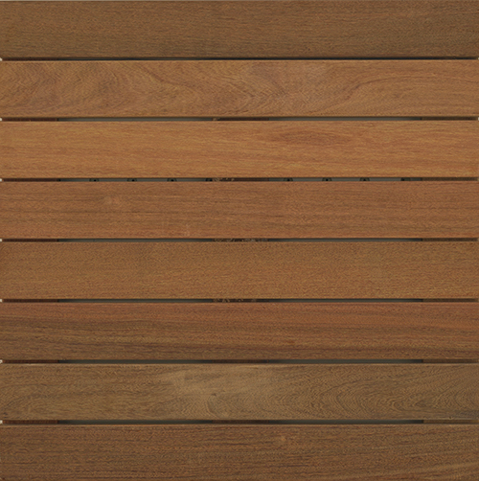 | GARAPA  WTGARAPA24-8PLANK-SMOOTH  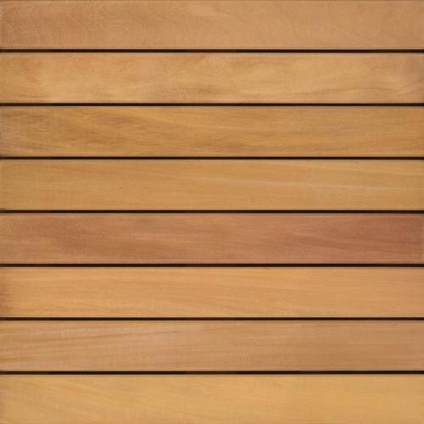 | IPÊ  WTIPE48-SMOOTH  or RIBBED  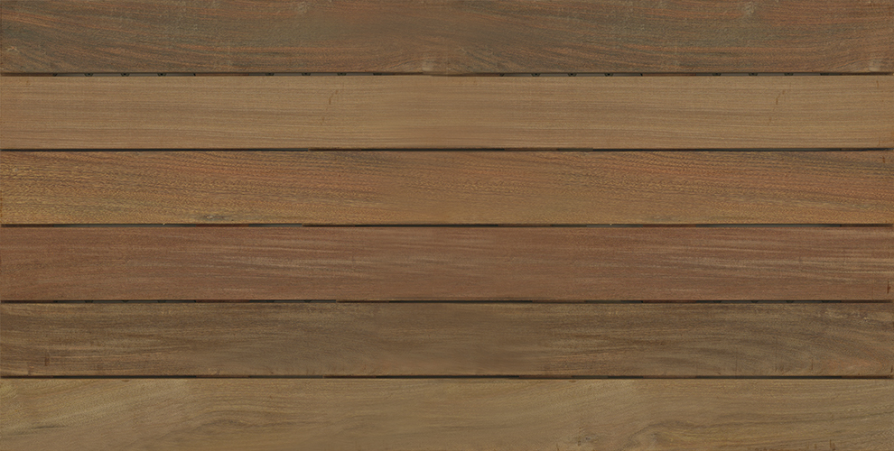 | IPÊ  WTIPE48-ARTISAN-  SMOOTH  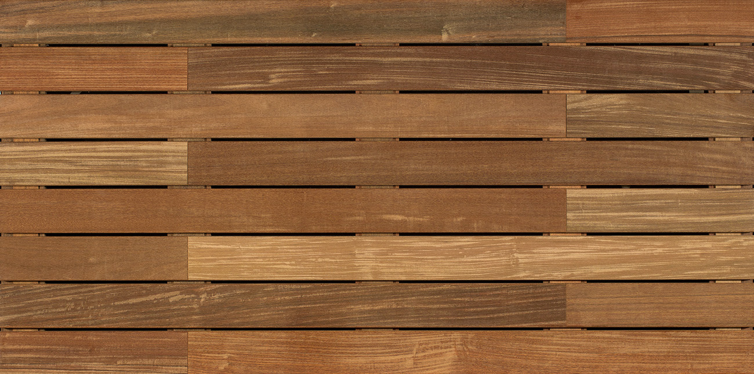
YELLOW BALAU  WTYELLOWBALAU-8PLANK-SMOOTH  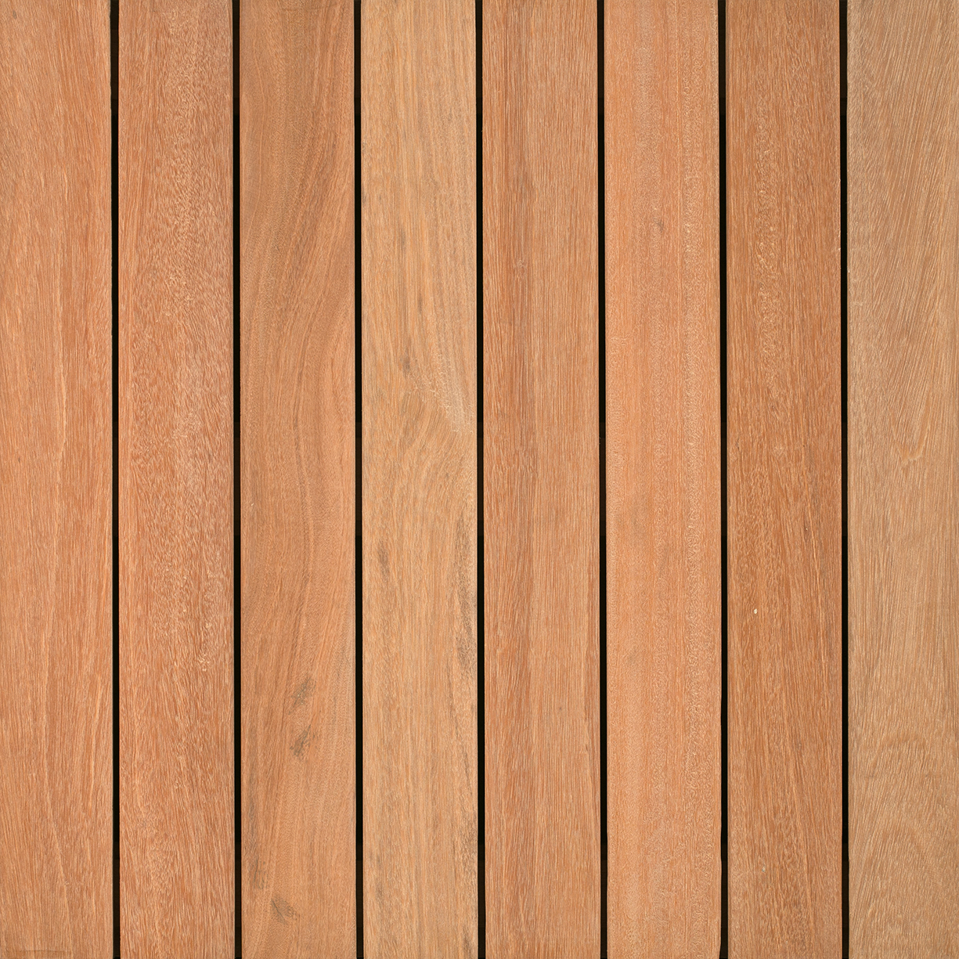 | FSC© MASSARANDUBA  WTFSC-100%-MASSARANDUBA24-8PLANK-SMOOTH  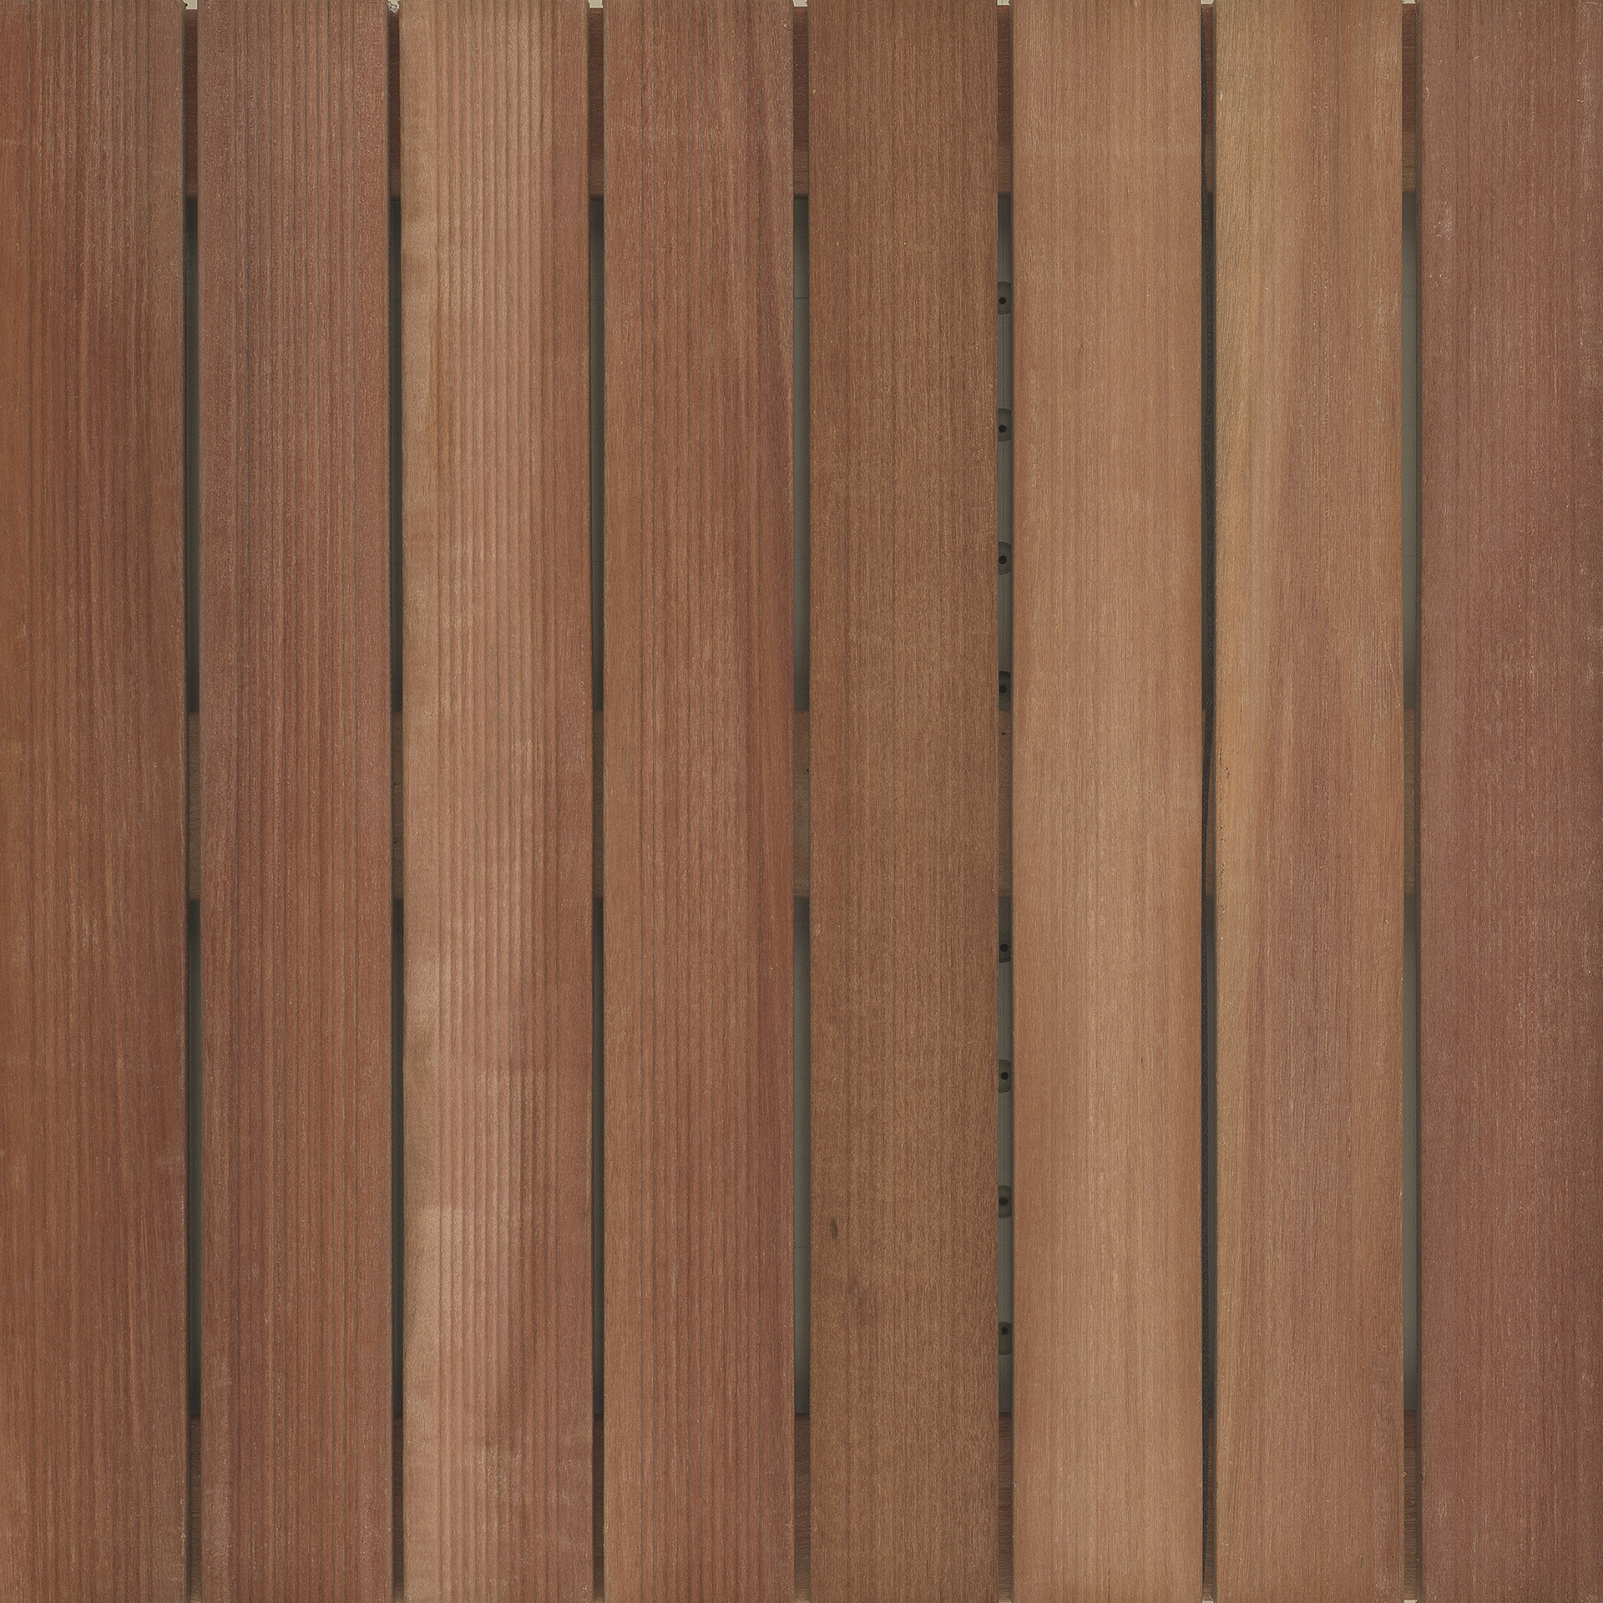 | FSC© IPÊ  WTFSC-100%-IPE24-8PLANK-SMOOTH  (48” LENGTH AVAILABLE)  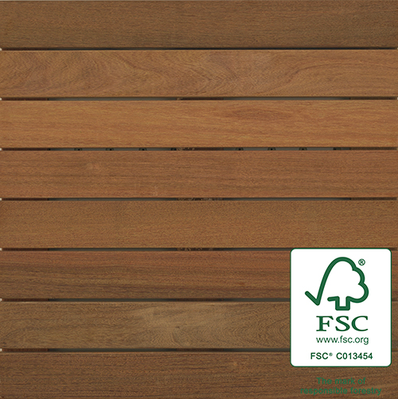 | JATOBA  WTJATOBA24-8PLANK-SMOOTH  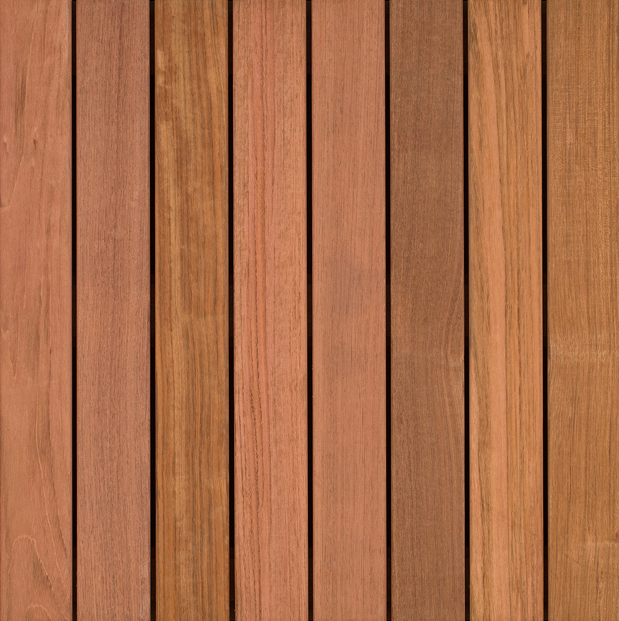
CUMARU  WTCUMARU24-8PLANK-SMOOTH (RIBBED SO)  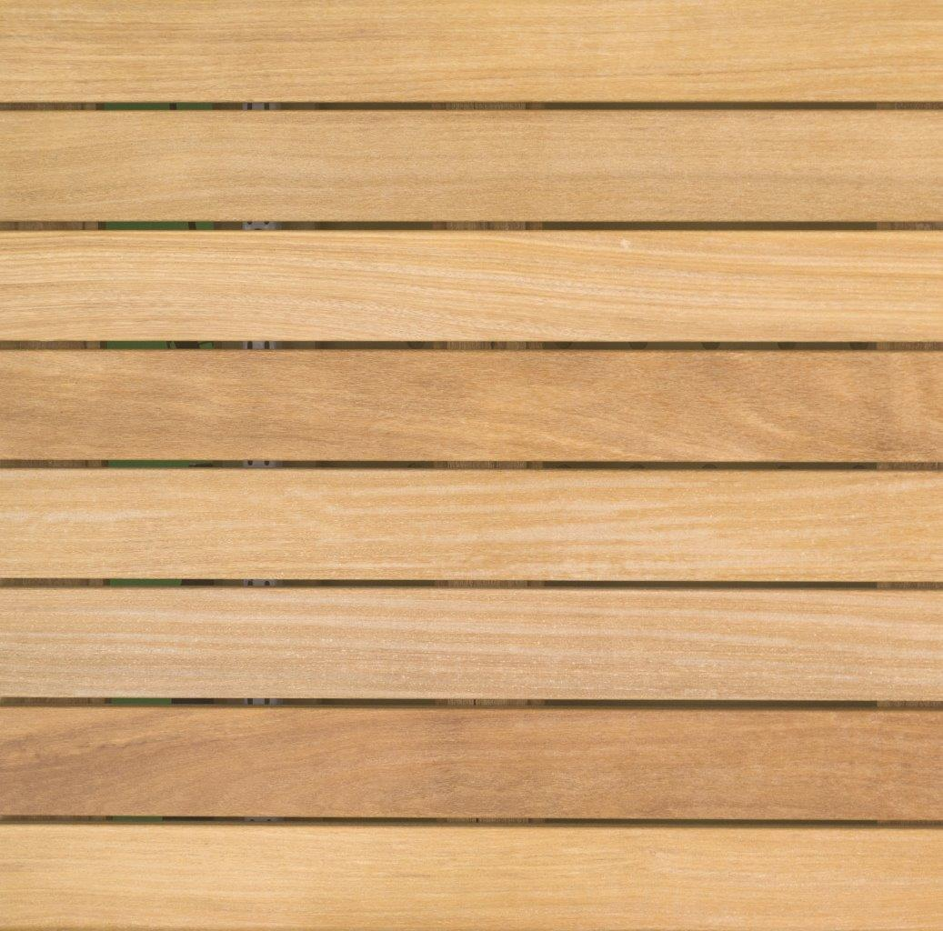 | CUMARU  WTCUMARU48-8PLANK-SMOOTH  (RIBBED SO)  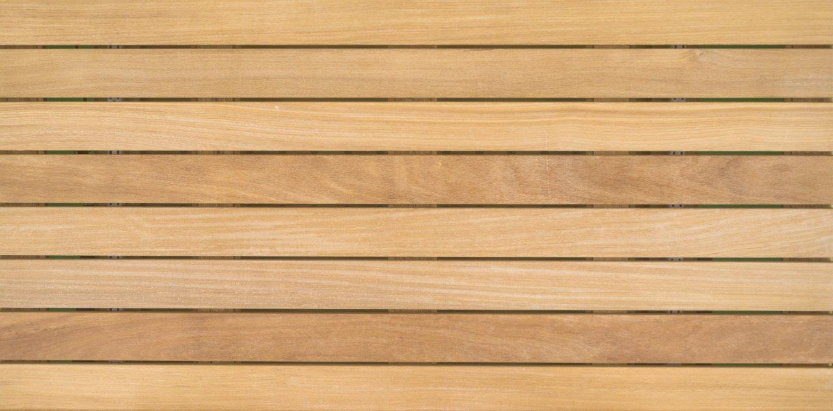 | FSC© CUMARU  WTFSC-100%-CUMARU24-8PLANK-SMOOTH (48” LENGTH AVAILABLE)  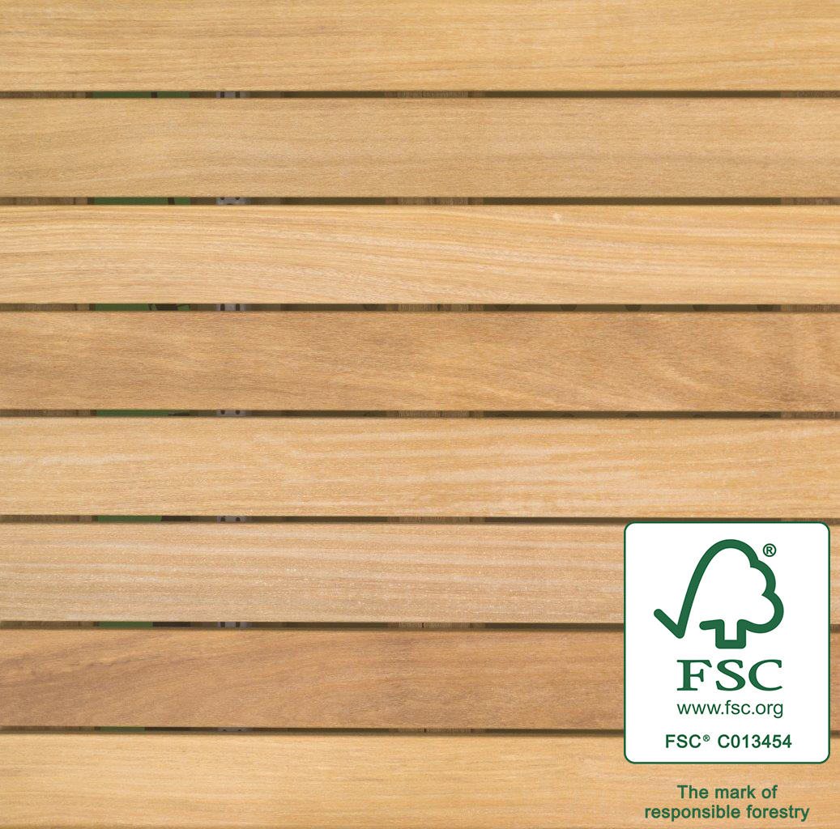 | BAMBOO  WTBAMBOO24-  5PLANK-SMOOTH  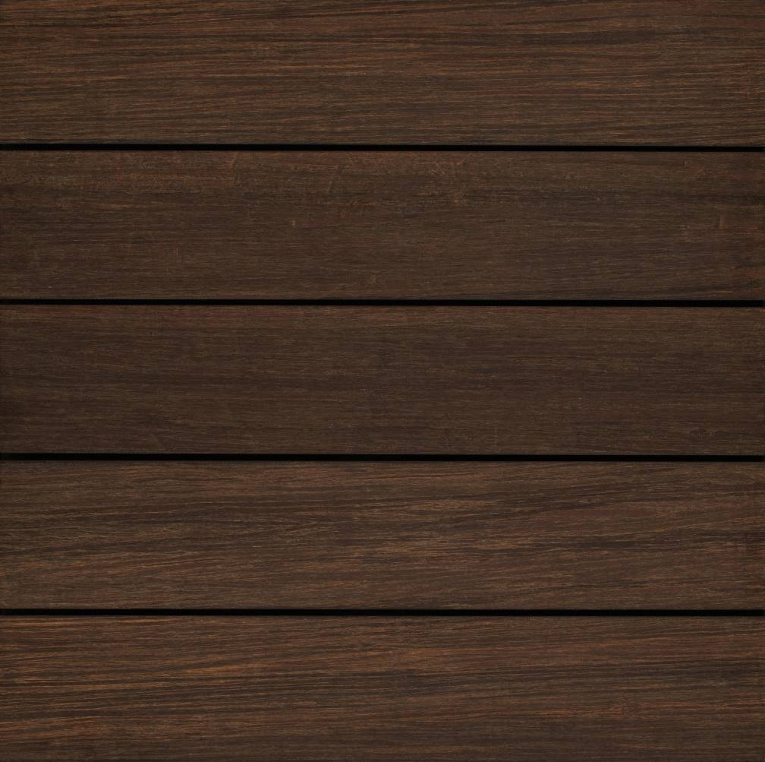
FSC© GARAPA  WTFSC-100%-GARAPA24-SMOOTH  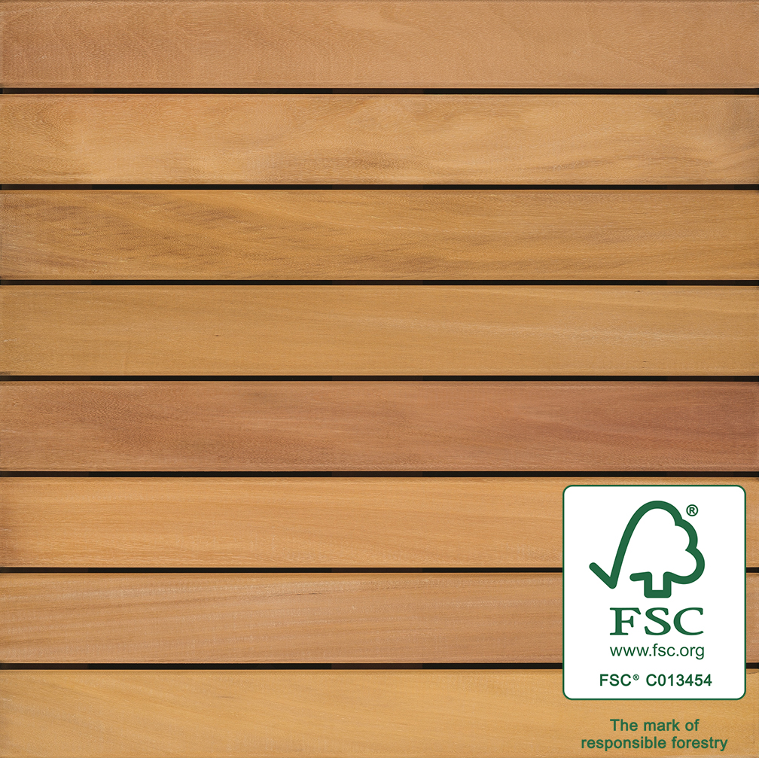 | ITAUBA  WTITAUBA24-8PLANK-SMOOTH  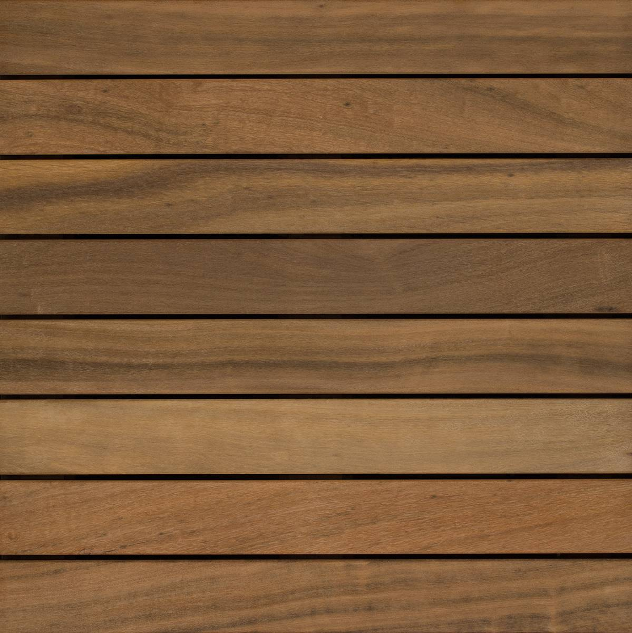 | TIGERWOOD  WTTIGERWOOD24-8PLANK-SMOOTH  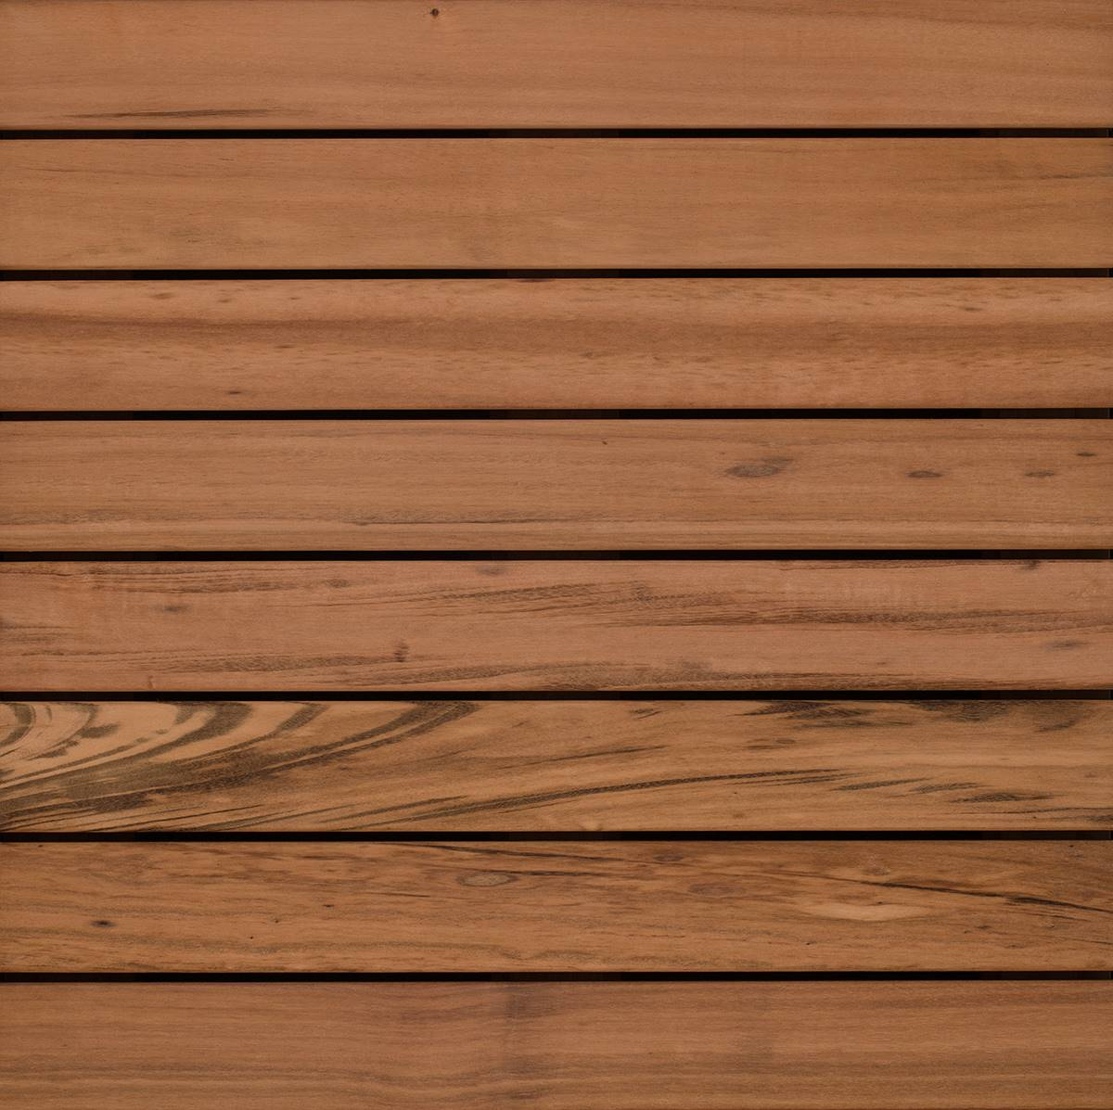 | FS-1  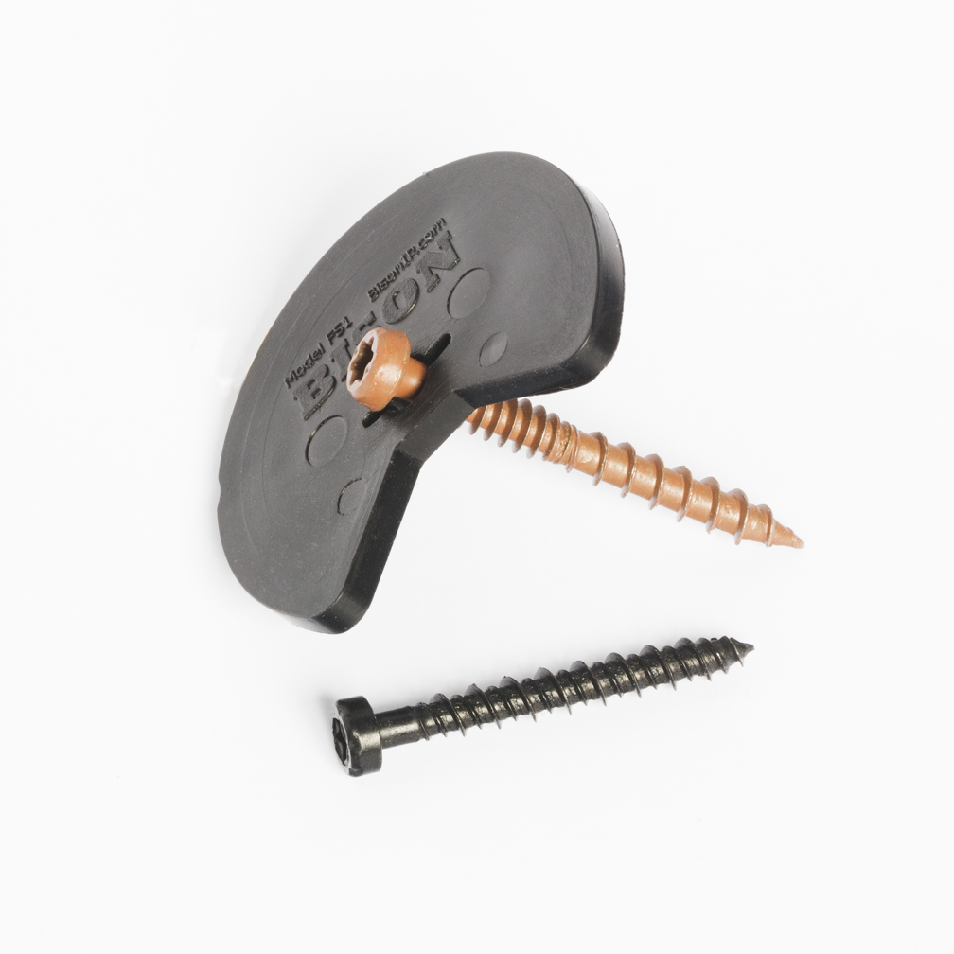  FS-12-WT  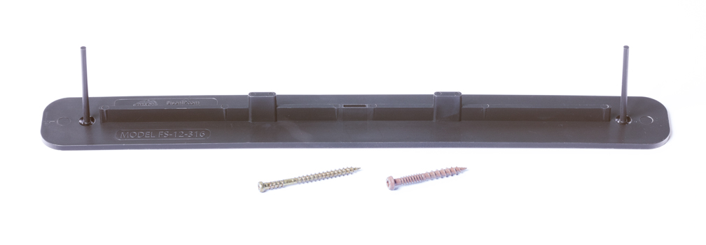
SO (SPECIAL ORDER)

*Wood tile colors may differ from photos and change without notice.
**Tigerwood hues will vary between growth patterns, and some planks may not exhibit the signature striping.
***Unless specified in the item number above, tile slat sizes may vary and will be determined by availability at the time of order. Bison recommends ordering enough tiles to complete each project.

