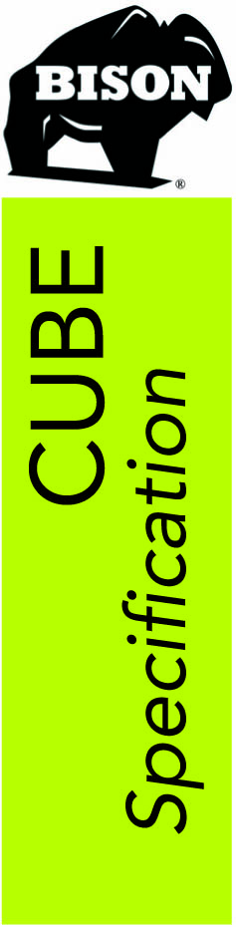

Bison Innovative Products
701 Osage Street, Unit 120
Denver, CO 80204
info@bisonip.com
www.bisonip.com

Phone 303-892-0400
Toll Free 800-333-423
Fax 303-825-5988

January 2026

Planters, seating, or storage – with modular Bison Cube™ site furnishings, the choice is yours. Bison Cubes make it easy to design a comfortable and beautiful outdoor environment. Bison Cubes integrate seamlessly with Bison Deck Systems. Instead of installing a Bison Wood Tile, set a Bison Cube in its place to use as a planter or add a Bison Ipê Cube Top for seating and storage.

Bison Cubes for use with Bison Pedestals Specification
SECTION 329433 Planters

- GENERAL

  - SECTION INCLUDES
    - Bison Cube for use as stand-alone planter or use with pedestal systems.

  - RELATED SECTIONS
** NOTE TO SPECIFIER ** Delete any sections below not relevant to this project; add others as required.
    - Section 129000 – Other Furnishings.
    - Section 323300 – Site Furnishings.
    - Section 018313 – Superstructure Performance Requirements.

  - REFERENCES
** NOTE TO SPECIFIER ** Delete references from the list below that are not actually required by the text of the edited section.
    - ADA - Americans with Disabilities Act requirements.

  - SUBMITTALS
    - Submit under provisions of Section 013300.
    - Product Data: Manufacturer's data sheets on each product to be used, including:
      - Preparation instructions and recommendations.
      - Storage/Handling requirements and recommendations.
      - Installation methods.
    - Shop Drawings: Complete details of layout and assembly, showing sizes and part identification, fasteners, anchors, and fittings.
    - Selection Samples: Color selections shall be made from the Manufacturer's brochure representing Manufacturer's full range of available colors and patterns.

  - QUALITY ASSURANCE
    - Manufacturer Qualifications: All primary products in this section will be supplied by a single Manufacturer with five (5) years of experience minimum.
    - Installer Qualifications: The Installer must have a minimum of two (2) years proven construction experience, be capable of estimating and building from blueprint plans and details, determine elevations and properly handle materials. All work must comply with the Bison installation procedures for assembling and installing site furnishings specified herein.
    - Special Considerations: The Contractor assumes the responsibility for and must take into consideration the structural capability and adequacy of the structure below to carry the dead and live load weight(s) involved, and when appropriate, make sure that the density of any insulation is satisfactory to resist crushing and damaging the waterproofing membrane.
    - The Bison Pedestal System is not intended to be part of a ballasted roofing system and does not shield the underlying roofing system from wind or other loads. The underlying roofing system must be capable of resisting the full design wind or other loads appropriate for a specific project.
** NOTE TO SPECIFIER ** Include a mock-up if the project size and/or quality warrant taking such a precaution. The following is one example of how a mock-up on a large project might be specified. When deciding on the extent of the mock-up, consider all the major different types of work on the project.
    - Mock-Up: Provide a mock-up for evaluation of surface preparation techniques and application workmanship.
      - Finish areas designated by Architect.
      - Do not proceed with remaining work until workmanship, color, and sheen are approved by Architect (if applicable).
      - Refinish mock-up area as required to produce acceptable work.

  - DELIVERY, STORAGE, AND HANDLING
    - Do not deliver to job site until conditions are ready for installation.
    - Immediately upon receipt inspect all delivered materials to ensure they are undamaged and in good condition. Claims for damages must be made to the Driver/Carrier prior to accepting delivery. Note any visual damage to containers or packaging material on the bill of lading before the Driver leaves. Any damage should be noted on the bill of lading, photographed, and then reported to Bison immediately.
    - All Bison Cubes should be removed from the original packaging and stored indoors until installation begins; do not leave products tightly wrapped as condensation can build up between the shrink wrap and planter, foam and planter, cardboard and planter, or any combination of materials, and could stain and/or begin to remove finishes. Do not store Bison Cubes or Tops in standing water.
    - Care should be taken in the handling, placement, and maintenance of Bison Cubes. While the Cubes are extremely durable, care should be taken to not scratch, dent, or drop the Cubes. It is also recommended that clean gloves be used during handling and installation to limit exposure to grease and other contaminants.

  - PROJECT CONDITIONS
    - There are no installation temperature restriction guidelines prescribed by Bison that limit deck installation work other than the practical considerations of working in any unsafe condition or inclement weather.
    - Bison Cubes specified for use on pedestals are to be used with pedestrian decks only.
    - Bison recommends setting Cubes directly on top of Pedestals. If setting Cubes on top of the decking surface itself, special consideration must be taken to ensure positive drainage and prevent pooling water beneath the Cubes.

  - ROOFTOP APPLICATIONS USING BISON DECK SUPPORTS
    - Bison Cubes specified for use on pedestals must be restrained by perimeter blocking or walls on all sides. Lateral movement greater than 3/16 max is unacceptable.
    - The total weights of dead and live loads must be calculated and dispersed evenly over the number of pedestals needed to carry the expected weight.
    - When installing Bison Cubes, additional support may be needed under the center and corners of the Cubes depending on the size and anticipated weight loads. A minimum of one additional pedestal support must be installed in the middle of each cube and for every 500 lbs (or portion thereof) of static loading.

  - ON GRADE APPLICATIONS
    - Bison recommends setting Cubes directly on top of Pedestals. If setting Cubes on grade, special considerations must be taken to ensure positive drainage and prevent pooling water beneath the Cubes.

  - CONTAINER FILL
    - Do not use soil weighing in excess of 25-50 lbs/cubic foot.
    - The bottom of extra-large and tall Cubes can be filled with lightweight filler. Consult your landscape professional for more information on fillers that work with the desired plantings.
    - The substrate immediately below the Cubes and pedestals shall provide positive drainage.
    - In the case of decks over roofing substrates, roof systems must meet local building code and be in accordance with the NRCA recommended good construction practices. Only roofing manufacturer approved systems shall be used.
** NOTE TO SPECIFIER ** Retain the next paragraph only if the pedestal system is installed over a roofing or waterproofing membrane. Delete if not required.
    - Additional rooftop pedestal installation instructions must be followed and can be found in Bison Pedestal Specifications. NOTE: Bison Pedestals and Cubes must be installed on surfaces with a minimum 40 psi bearing capacity.

  - APPLICATIONS/SCOPE
    - Furnish and install Bison Cubes for use on grade without pedestal support.
    - Furnish and install Bison Cubes that integrate with the Bison Pedestal System.
    - Consult the Manufacturer and the Project Engineer regarding the following:
      - When spacer tab condition or design requires spacing between decking tiles or Cubes other than the standard spacing required by the Manufacturer.
      - When the required pedestal height exceeds the safe limits as determined by the Manufacturer.
      - When planter or pedestal load capacity exceeds the maximum listed.
      - When anticipating installation of any items with excess weight on top of the deck.
      - When using Bison Pedestals on grade (soil).
      - When greater pedestal load capacity is required.

  - WARRANTY
    - At project closeout and upon request, Bison can provide to the Owner or Owner’s Representative an executed copy of the Manufacturer’s standard document outlining the terms, conditions, and limitations of their limited warranty against manufacturing defects for a period of five (5) years. Bison must approve all warranty related repairs, and unauthorized repairs void this limited warranty.
    - The Contractor warrants that his work will remain free from defects of labor and materials used in conjunction with his work in accordance with the General Conditions for this project or a minimum of five (5) years.
    - It is the responsibility of the Contractor installing the product listed in this section to coordinate warranty requirements with any related sections or adjacent work. Notify the Architect immediately of any potential lapses or limitations in warranty coverage.
    - Bison Aluminum Cubes and Ipê Wood Cubes and Tops are covered by a limited five (5) year warranty. Bison Aluminum Cubes and Ipê Wood Cubes and Tops are warrantied to the original owner to be free of defects in material and workmanship for the period of five (5) years from the date of purchase. This warranty also extends to defects caused by wood rot and insect infestation for the same period. Defects are defined as imperfections that impair the utility of the product. This warranty applies to conditions of normal use and does not apply to damage resulting from abuse, excess weight, or acts of nature. This warranty does not apply to non-structural surface cracks or to variations in wood color due to weathering. If an Aluminum Cube or Ipê Wood Cube or Top is deemed defective within the terms of the warranty, Bison may make repairs or provide for repair services at no cost to the customer. If a repair cannot be made, a replacement Aluminum Cube or Ipê Wood Cube or Top will be furnished at no cost to the customer. This warranty does not cover shipping damage. Shipping damage must be reported directly to Bison immediately upon receipt of products. Please save all product packaging for a short period of time in case return shipping is required. Bison makes no other warranties, either express or implied, with respect to the use of the Bison Aluminum Cube or Ipê Wood Cube or Top, including warranties of merchantability or fitness for a particular purpose.

  - MANUFACTURERS
** NOTE TO SPECIFIER ** Retain one of the following paragraphs 1.13 A-C; to coordinate with requirements of Division 1 section on product options and substitutions.
    - Acceptable Cube Manufacturer: Bison Innovative Products, 701 Osage Street, Unit 120, Denver, CO 80204.
Toll Free 800-333-4234. Phone 303-892-0400. Fax 303-825-5988. Email: info@bisonip.com. Website: www.bisonip.com.
    - Substitutions: Not permitted.
    - Requests for substitutions will be considered in accordance with provisions of Section 012500.

- PRODUCTS

  - BISON CUBES
    - Bison Cubes integrate with Bison Pedestals. Aluminum Cubes contain recycled content and can contribute to LEED points. Bison Pedestals and Aluminum Cubes are proudly made in the USA.

** NOTE TO SPECIFIER ** Edit the following sections on Cubes/Cube Tops removing those products which are not applicable.
    - Standard Aluminum Cube Colors and Finishes: Powder Coated. Applies to ALL Bison Aluminum Cubes.
** NOTE TO SPECIFIER ** Select one of the following selections as required, delete those which do not pertain.
    - Low VOC sealants and powder coat finishes meet FDA reference Test Method 24, ASTM D2369 for determination for volatile content.
    - As selected by the Architect from Manufacturer’s ten (10) standard colors and finishes:
      - Red
      - Charcoal
      - White
      - Black
      - Bronze
      - Silver
      - Forest Green
      - Terracopper
      - Midnight Blue
      - Oxidized Zinc Patina
    - Custom color as selected by Architect (additional cost associated with custom colors)

  - BISON ALUMINUM CUBES
    - Model: CUBE-PC242420 – Bison Powder Coated Aluminum Cube
      - Length/Width/Height: 23.875 inches x 23.875 inches x 20 inches (606mm x 606mm x 508mm).
      - Weight: 28 lbs (12.7 kg)
      - Material: 0.09” (2.3mm) thick aluminum.
      - Recycled Content: Typically contain 20% recycled content and are 100% recyclable.
      - Drainage:
        - Drainage hole(s) and irrigation sleeve standard.
        - Drainage fittings by special order.
      - Mounting:
** NOTE TO SPECIFIER ** Select one the following mounting types as required and delete those not required.
        - Free standing.
        - On Bison Pedestals: Place corner of Cube onto a Bison Pedestal as directed in installation instructions. In addition, place one or more Pedestals in the center or along the sides of the Cube to support anticipated weights.
    - Model: CUBE-PC242424 – Bison Powder Coated Aluminum Cube
      - Length/Width/Height: 23.875 inches x 23.875 inches x 24 inches (606mm x 606mm x 610mm).
      - Weight: 30 lbs (13.6 kg)
      - Material: 0.09” (2.3mm) thick aluminum.
      - Recycled Content: Typically contain 20% recycled content and are 100% recyclable.
      - Drainage:
        - Drainage hole(s) and irrigation sleeve standard.
        - Drainage fittings by special order.
      - Mounting:
** NOTE TO SPECIFIER ** Select one the following mounting types as required and delete those not required.
        - Free standing.
        - On Bison Pedestals: Place corner of Cube onto a Bison Pedestal as directed in installation instructions. In addition, place one or more Pedestals in the center or along the sides of the Cube to support anticipated weights.
    - Model: CUBE-PC242436 - Bison Powder Coated Aluminum Cube
      - Length/Width/Height: 23.875 inches x 23.875 inches x 36 inches (606mm x 606mm x 914mm).
      - Weight: 42 lbs (19.1 kg)
      - Material: 0.09” (2.3mm) thick aluminum.
      - Recycled Content: Typically contain 20% recycled content and are 100% recyclable.
      - Drainage:
        - Drainage hole(s) and irrigation sleeve standard.
        - Drainage fittings by special order.
      - Mounting:
** NOTE TO SPECIFIER ** Select one the following mounting types as required and delete those not required.
        - Free standing.
        - On Bison Pedestals: Place corner of Cube onto a Bison Pedestal as directed in installation instructions. In addition, place one or more Pedestals in the center or along the sides of the Cube to support anticipated weights.
    - Model: CUBE-PC482420 - Bison Powder Coated Aluminum Cube
      - Length/Width/Height: 47.9375 inches x 23.875 inches x 20 inches (1218mm x 606mm x 508mm).
      - Weight: 45 lbs (20.5 kg)
      - Material: 0.09” (2.3mm) thick aluminum.
      - Recycled Content: Typically contain 20% recycled content and are 100% recyclable.
      - Drainage:
        - Drainage hole(s) and irrigation sleeve standard.
        - Drainage fittings by special order.
      - Mounting:
** NOTE TO SPECIFIER ** Select one the following mounting types as required and delete those not required.
        - Free standing.
        - On Bison Pedestals: Place corner of Cube onto a Bison Pedestal as directed in installation instructions. In addition, place one or more Pedestals in the center or along the sides of the Cube to support anticipated weights.
    - Model: CUBE-PC482424 – Bison Powder Coated Aluminum Cube
      - Length/Width/Height: 47.9375 inches x 23.875 inches x 24 inches (1218mm x 606mm x 610mm).
      - Weight: 50 lbs (22.7 kg)
      - Material: 0.09” (2.3mm) thick aluminum.
      - Recycled Content: Typically contain 20% recycled content and are 100% recyclable.
      - Drainage:
        - Drainage hole(s) and irrigation sleeve standard.
        - Drainage fittings by special order.
      - Mounting:
** NOTE TO SPECIFIER ** Select one the following mounting types as required and delete those not required.
        - Free standing.
        - On Bison Pedestals: Place corner of Cube onto a Bison Pedestal as directed in installation instructions. In addition, place one or more Pedestals in the center or along the sides of the Cube to support anticipated weights.
    - Model: CUBE-PC482436 - Bison Powder Coated Aluminum Cube
      - Length/Width/Height: 47.9375 inches x 23.875 inches x 36 inches (1218mm x 606mm x 914mm).
      - Weight: 66 lbs (29.9 kg)
      - Material: 0.125” (3.2mm) thick aluminum.
      - Recycled Content: Typically contain 20% recycled content and are 100% recyclable.
      - Drainage:
        - Drainage hole(s) and irrigation sleeve standard.
        - Drainage fittings by special order.
      - Mounting:
** NOTE TO SPECIFIER ** Select one the following mounting types as required and delete those not required.
        - Free standing.
        - On Bison Pedestals: Place corner of Cube onto a Bison Pedestal as directed in installation instructions. In addition, place one or more Pedestals in the center or along the sides of the Cube to support anticipated weights.
    - Model: CUBE-PC484820 - Bison Powder Coated Aluminum Cube
      - Length/Width/Height: 47.9375 inches x 47.9375 inches x 20 inches (1218mm x 1218mm x 508mm).
      - Weight: 131 lbs (59.5 kg)
      - Material: 0.188” (4.8mm) thick aluminum.
      - Recycled Content: Typically contain 20% recycled content and are 100% recyclable.
      - Drainage:
        - Drainage hole(s) and irrigation sleeve standard.
        - Drainage fittings by special order.
      - Mounting:
** NOTE TO SPECIFIER ** Select one the following mounting types as required and delete those not required.
        - Free standing.
        - On Bison Pedestals: Place corner of Cube onto a Bison Pedestal as directed in installation instructions. In addition, place one or more Pedestals in the center or along the sides of the Cube to support anticipated weights.
    - Model: CUBE-PC484824 – Bison Powder Coated Aluminum Cube
      - Length/Width/Height: 47.9375 inches x 47.9375 inches x 24 inches (1218mm x 1218mm x 610mm).
      - Weight: 150 lbs (68.0 kg)
      - Material: 0.188” (4.8mm) thick aluminum.
      - Recycled Content: Typically contain 20% recycled content and are 100% recyclable.
      - Drainage:
        - Drainage hole(s) and irrigation sleeve standard.
        - Drainage fittings by special order.
      - Mounting:
** NOTE TO SPECIFIER ** Select one the following mounting types as required and delete those not required.
        - Free standing.
        - On Bison Pedestals: Place corner of Cube onto a Bison Pedestal as directed in installation instructions. In addition, place one or more Pedestals in the center of along the sides of the Cube to support anticipated weights.
    - Model: CUBE-PC484836 - Bison Powder Coated Aluminum Cube
      - Length/Width/Height: 47.9375 inches x 47.9375 inches x 36 inches (1218mm x 1218mm x 914mm).
      - Weight: 191 lbs (86.8 kg)
      - Material: 0.188” (4.8mm) thick aluminum.
      - Recycled Content: Typically contain 20% recycled content and are 100% recyclable.
      - Drainage:
        - Drainage hole(s) and irrigation sleeve standard.
        - Drainage fittings by special order.
      - Mounting:
** NOTE TO SPECIFIER ** Select one the following mounting types as required and delete those not required.
        - Free standing.
        - On Bison Pedestals: Place corner of Cube onto a Bison Pedestals as directed in installation instructions. In addition, place one or more Pedestals in the center or along the sides of the Cube to support anticipated weights.
    - Model: CUBE-PC722420 – Bison Powder Coated Aluminum Cube
      - Length/Width/Height: 72 inches x 23.875 inches x 20 inches (1829mm x 606mm x 508mm).
      - Weight: 85 lbs (38.6 kg)
      - Material: 0.125” (3.2mm) thick aluminum.
      - Recycled Content: Typically contain 20% recycled content and are 100% recyclable.
      - Drainage:
        - Drainage hole(s) and irrigation sleeve standard.
        - Drainage fittings by special order.
      - Mounting:
** NOTE TO SPECIFIER ** Select one the following mounting types as required and delete those not required.
        - Free standing.
        - On Bison Pedestals: Place corner of Cube onto a Bison Pedestal as directed in installation instructions. In addition, place one or more Pedestals in the center of along the sides of the Cube to support anticipated weights.
    - Model: CUBE-PC722424 – Bison Powder Coated Aluminum Cube
      - Length/Width/Height: 72 inches x 23.875 inches x 24 inches (1827mm x 606mm x 610mm).
      - Weight: 95 lbs (43.1 kg)
      - Material: 0.125” (3.2mm) thick aluminum.
      - Recycled Content: Typically contain 20% recycled content and are 100% recyclable.
      - Drainage:
        - Drainage hole(s) and irrigation sleeve standard.
        - Drainage fittings by special order.
      - Mounting:
** NOTE TO SPECIFIER ** Select one the following mounting types as required and delete those not required.
        - Free standing.
        - On Bison Pedestals: Place corner of Cube onto a Bison Pedestal as directed in installation instructions. In addition, place one or more Pedestals in the center of along the sides of the Cube to support anticipated weights.
    - Model: CUBE-PC722436 – Bison Powder Coated Aluminum Cube
      - Length/Width/Height: 72 inches x 23.875 inches x 36 inches (1827mm x 606mm x 914mm).
      - Weight: 125 lbs (56.7 kg)
      - Material: 0.125” (3.2mm) thick aluminum.
      - Recycled Content: Typically contain 20% recycled content and are 100% recyclable.
      - Drainage:
        - Drainage hole(s) and irrigation sleeve standard.
        - Drainage fittings by special order.
      - Mounting:
** NOTE TO SPECIFIER ** Select one the following mounting types as required and delete those not required.
        - Free standing.
        - On Bison Pedestals: Place corner of Cube onto a Bison Pedestal as directed in installation instructions. In addition, place one or more Pedestals in the center of along the sides of the Cube to support anticipated weights.
    - Model: CUBE-PC962420 – Bison Powder Coated Aluminum Cube
      - Length/Width/Height: 96.0625 inches x 23.875 inches x 20 inches (2440mm x 606mm x 508mm).
      - Weight: 165 lbs (74.8 kg)
      - Material: 0.125” (3.2mm) thick aluminum.
      - Recycled Content: Typically contain 20% recycled content and are 100% recyclable.
      - Drainage:
        - Drainage hole(s) and irrigation sleeve standard.
        - Drainage fittings by special order.
      - Mounting:
** NOTE TO SPECIFIER ** Select one the following mounting types as required and delete those not required.
        - Free standing.
        - On Bison Pedestals: Place corner of Cube onto a Bison Pedestal as directed in installation instructions. In addition, place one or more Pedestals in the center of along the sides of the Cube to support anticipated weights.
    - Model: CUBE-PC962424 – Bison Powder Coated Aluminum Cube
      - Length/Width/Height: 96.0625 inches x 23.875 inches x 24 inches (2440mm x 606mm x 610mm).
      - Weight: 185 lbs (83.9 kg)
      - Material: 0.188” (4.8mm) thick aluminum.
      - Recycled Content: Typically contain 20% recycled content and are 100% recyclable.
      - Drainage:
        - Drainage hole(s) and irrigation sleeve standard.
        - Drainage fittings by special order.
      - Mounting:
** NOTE TO SPECIFIER ** Select one the following mounting types as required and delete those not required.
        - Free standing.
        - On Bison Pedestals: Place corner of Cube onto a Bison Pedestal as directed in installation instructions. In addition, place one or more Pedestals in the center of along the sides of the Cube to support anticipated weights.
    - Model: CUBE-PC962436 – Bison Powder Coated Aluminum Cube
      - Length/Width/Height: 96.0625 inches x 23.875 inches x 36 inches (2440mm x 606mm x 914mm).
      - Weight: 240 lbs (108.9 kg)
      - Material: 0.188” (4.8mm) thick aluminum.
      - Recycled Content: Typically contain 20% recycled content and are 100% recyclable.
      - Drainage:
        - Drainage hole(s) and irrigation sleeve standard.
        - Drainage fittings by special order.
      - Mounting:
** NOTE TO SPECIFIER ** Select one the following mounting types as required and delete those not required.
        - Free Standing
        - On Bison Pedestals: Place corner of Cube onto a Bison Pedestal as directed in installation instructions. In addition, place one or more Pedestals in the center of along the sides of the Cube to support anticipated weights.
    - Model: CUBE-TRAY241202 – Bison Silver Powder Coated Aluminum Tray
      - Length/Width/Height: 23.875 inches x 11.9375 inches x 1.69 inches (606mm x 303mm x 43mm).
      - Weight: 5 lbs (2.3 kg)
      - Material: 0.125” (3.2mm) thick aluminum.
      - Recycled Content: Typically contain 20% recycled content and are 100% recyclable.
      - Drainage: Drainage holes standard.
      - Mounting:
** NOTE TO SPECIFIER ** Select one the following mounting types as required and delete those not required.
        - Free standing.
        - On Bison Pedestals: Place corner of Cube onto a Bison Pedestal as directed in installation instructions. In addition, place one or more Pedestals in the center or along the sides of the Cube to support anticipated weights.
    - Model: CUBE-TRAY481202 – Bison Silver Powder Coated Aluminum Tray
      - Length/Width/Height: 47.9375 inches x 11.9375 inches x 1.69 inches (1218mm x 303mm x 43mm).
      - Weight: 10 lbs (4.5 kg)
      - Material: 0.125” (3.2mm) thick aluminum.
      - Recycled Content: Typically contain 20% recycled content and are 100% recyclable.
      - Drainage: Drainage holes standard.
      - Mounting:
** NOTE TO SPECIFIER ** Select one the following mounting types as required and delete those not required.
        - Free standing.
        - On Bison Pedestals: Place corner of Cube onto a Bison Pedestal as directed in installation instructions. In addition, place one or more Pedestals in the center of along the sides of the Cube to support anticipated weights.

  - BISON IPÊ WOOD CUBES AND TOPS
    - Model: CUBE-IPE242417-LINED – Bison Ipê Wood Cube
      - Width/Length/Height: 23.875 inches x 23.875 inches x 16.75 inches (606mm x 606mm x 425mm)
      - Weight: 70 lbs (31.8 kg)
      - Material: Ipê hardwood.
      - Liner: Acrylic copolymer lining standard.
      - Drainage:
        - Drainage hole(s) standard.
        - Drainage fittings by special order.
      - Important Considerations: Do not use bamboo or plants known to have aggressive root systems with Ipê Wood Cubes.
      - Finish: Natural wood.
        - Small checks and splits are normal and a natural part of the wood.
        - Wood stabilizers or sealants can preserve color, help mitigate the loss of moisture, and minimize checking and splitting.
      - Mounting:
** NOTE TO SPECIFIER ** Select one the following mounting types as required and delete those not required.
        - Free standing.
        - On Bison Pedestals: Place corner of Cube onto a Bison Pedestal as directed in installation instructions. In addition, place one or more Pedestals in the center or along the sides of the Cube to support anticipated weights.
    - Model: CUBE-IPE482417-LINED – Bison Ipê Wood Cube
      - Width/Length/Height: 47.9375 inches x 23.875 inches x 16.75 inches (1218mm x 606mm x 425mm)
      - Weight: 124 lbs (56.2 kg)
      - Material: Ipê hardwood.
      - Liner: Acrylic copolymer lining standard.
      - Drainage:
        - Drainage hole(s) standard.
        - Drainage fittings by special order.
      - Important Considerations: Do not use bamboo or plants known to have aggressive root systems with Ipê Wood Cubes.
      - Finish: Natural wood.
        - Small checks and splits are normal and a natural part of the wood.
        - Wood stabilizers or sealants can preserve color, help mitigate the loss of moisture, and minimize checking and splitting.
      - Mounting:
** NOTE TO SPECIFIER ** Select one the following mounting types as required and delete those not required.
        - Free standing.
        - On Bison Pedestals: Place corner of Cube onto a Bison Pedestal as directed in installation instructions. In addition, place one or more Pedestals in the center or along the sides of the Cube to support anticipated weights.
    - Model: CUBE-TOP-IPE2424 – Bison Single Ipê Cube Top
      - Specify:
        - Model: CUBE-TOP-IPE2424 if Top is to be placed on an Ipê Wood Cube.
        - Model: CUBE-TOP-IPE2424-AL if Top is to be placed on an Aluminum Cube.
      - Width/Length/Height: 23.875 inches x 23.875 inches x 1.575 inches (606mm x 606mm x 40mm).
      - Top adds 0.75” (19mm) to Cube height.
      - Weight:
        - Model: CUBE-TOP-IPE2424: 22 lbs (10 kg)
        - Model: CUBE-TOP-IPE2424-AL: 21 lbs (9.5 kg)
      - Material: Ipê hardwood.
      - Storage is weather resistant but not watertight.
      - Finish: Natural wood.
        - Small checks and splits are normal and a natural part of the wood.
        - Wood stabilizers or sealants can preserve color, help mitigate the loss of moisture, and minimize checking and splitting.
      - Mounting: Place on top of Cube.
    - Model: CUBE-TOP-IPE2448 – Bison Double Ipê Cube Top
      - Specify:
        - Model: CUBE-TOP-IPE2448 if Top is to be placed on an Ipê Wood Cube.
        - Model: CUBE-TOP-IPE2448-AL if Top is to be placed on an Aluminum Cube.
      - Width/Length/Height: 47.9375 inches x 23.875 inches x 1.575 inches (1218mm x 606mm x 40mm).
      - Top adds 0.75” (19mm) to Cube height.
      - Weight:
        - Model: CUBE-TOP-IPE2448: 43 lbs (19.5 kg)
        - Model: CUBE-TOP-IPE2448-AL: 41 lbs (18.6 kg)
      - Material: Ipê hardwood.
      - Storage is weather resistant but not watertight.
      - Finish: Natural wood.
        - Small checks and splits are normal and a natural part of the wood.
        - Wood stabilizers or sealants can preserve color, help mitigate the loss of moisture, and minimize checking and splitting.
      - Mounting: Place on top of Cube.

  - BISON CUSTOM CUBE PRODUCTS
    - Model: CUBE-CUSTOM – Bison Custom Cube Products
      - Specify Cube or Cube Top
      - Specify Dimensions: Width/Length/Height
      - Specify Material (for Cubes ONLY):
        - Powder Coated Aluminum Cube
          - Drainage: Drainage hole(s) and irrigation sleeve standard.
          - Specify Color:
            - Bison standard color (Red, Charcoal, White, Black, Bronze, Silver, Forest Green, Terracopper, Midnight Blue, or Oxidized Zinc Patina).
            - Custom color as selected by Architect (Custom color will incur an additional charge).
        - Ipê Wood Cube
          - Finish: Natural wood. Other wood species may be available for Cubes and Cube Tops, please inquire.
          - Liner: Acrylic copolymer lining standard.
          - Drainage: Drainage hole(s) standard.
      - Specify Mounting:
** NOTE TO SPECIFIER ** Select one the following mounting types as required and delete those not required.
        - Free standing (for Cubes ONLY).
        - On Bison Pedestals: Place corner of Cube onto a Bison Pedestal as directed in installation instructions. In addition, place one or more Pedestals in the center or along the sides of the Cube to support anticipated weights.
        - Place on top of Cube (for Cube Tops ONLY).

- EXECUTION

  - EXAMINATION
    - Prior to Bison Cube installation verify the following:
      - All elevations and deck dimensions are consistent with information submitted to Bison for quoting and/or take-off.
      - Anticipated live/dead loads in or on Bison Cubes are compatible with the deck system.
      - Substrates have been properly prepared, and the project is set to proceed. If substrate preparation is the responsibility of another Installer, notify Architect of unsatisfactory preparations before proceeding.

  - PREPARATION
    - The substrate surface that will receive the Pedestals and Cubes must be:
      - Well compacted if on-grade.
      - Structurally capable of carrying the dead and live loads anticipated if over occupied space.
      - Clean and free of debris that could impair the performance of the Pedestals or Cubes.

  - INSTALLATION
    - If a scenario is encountered during installation which is not covered, please contact Bison.
    - General Safety Precautions: Bison recommends wearing puncture resistant safety gloves when handling Cubes and Tops.
    - For use as Planters:
      - Place landscape fabric on the bottom of the containers to prevent soil from falling through drainage holes.
      - Container Fill:
        - Do not use soil weighing in excess of 25-50 lbs/cubic foot.
        - The bottom of extra-large and tall planters can be filled with lightweight filler. Consult your landscape professional for more information on fillers that work with the desired plantings.
    - For use as Storage: Storage provided by Bison Cubes with Ipê Wood Cube Tops is weather resistant not watertight.
    - Surface Mounting: Place Cube on level, structurally sound surface.
    - Pedestal Mounting:
      - Refer to Bison Pedestal Specifications and Details for complete Pedestal installation instructions.
      - If needed, install additional pedestals under Cubes to support anticipated dead and live loads.
        - Additional center pedestal support is required for each incremental 500 lb load increase.
        - Pedestals should support each corner, and the center, underneath the Cube at 2-foot (24”) intervals.
        - Contact Bison for information regarding center support of Aluminum Cubes.
      - Install in accordance with Bison and other contributing Manufacturers’ installation instructions.

  - FIELD QUALITY CONTROL
    - During Installation:
      - Inspect construction process regularly to ensure that gridlines and spacing are being maintained in a straight and consistent pattern, lateral motion is restricted, and the Cubes and Pedestals are level and not rocking; shim as required.
      - Confirm that Cube height (height above parapet/bearing surface) complies with any federal, state, or local regulations.
      - Inspect to ensure that all perimeter sides of the deck system are securely contained to restrain all sides of the deck. Surface materials must fit tightly against all pedestal spacing tabs, and the gap or space at all perimeter edges must not exceed one tab width or 3/16” (4.5 mm).
      - While Bison Cubes are durable, they can be damaged by mishandling or careless treatment. If tools or equipment are dropped against a Cube surface, chips, cracks, gouges, scratches, or other surface damage may occur. If exposed to nearby construction, pay special attention to keeping the Ipê Wood Cubes and Ipê Wood Cube Tops clear of metal shavings or filings as there could be a reaction causing discoloration.
    - Immediately Following Installation: The Owner, or the Owner’s Agent, shall carefully inspect the deck system to be positive that:
      - The new deck system is adequately blocked on all sides to contain the surface decking and related components.
      - There is no more than one tab width spacing between Cubes and surface materials or from perimeter containment [not to exceed 3/16” (4.5 mm)].
      - There is no rocking of the Cube(s) or surface materials.
      - All required spacer tabs and fastening kits are installed and secure.
      - The installed Cubes are protected from damage which may result from continued site construction.
    - After Installation: The Installer and/or Architect has the responsibility of informing the Owner about performing routine maintenance on the deck. This includes:
      - Checking for rocking surface materials and properly applying shims as the substrate can settle and require Pedestal adjustment.
      - Periodically checking for broken, damaged, or missing tab sets and replacing them to limit deck movement.
      - Maintaining intact and structurally sound perimeter containment.
      - Retaining extra surface materials in a convenient location for future replacements.

  - CUBE CARE AND MAINTENANCE RECOMMENDATIONS
**NOTE TO SPECIFIER** Add any additional maintenance which might be required by the Owner including specified Cube treatments.
    - Aluminum Cubes
      - Powder Coated Aluminum Cubes should be inspected regularly for soil deposits and environmental contaminants. These contaminants should be removed with a soft cloth and mild soapy water while the surface of the Cube is cool to the touch. Rinse the Cube thoroughly after each cleaning with mineral-free clean water. Take care to keep the cleaning agents from affecting the surrounding area. Harsh environments may require more frequent inspections and cleaning. Bison recommends cleaning a small area first to ensure there will be no unforeseen discoloration.
      - Oxidized Zinc Patina Aluminum Cubes have a “living” finish that will change over time. This finish is susceptible to stains and other environmental contaminants. Care should be taken in its handling, placement and maintenance. Do not clean or scrub the zinc finish with any solvents or cleaners of any kind. Lightly spray with water to clean. Do not use a power washer.
      - In the event of damage please contact Bison at 800.333.4234 or sales@bisonip.com.
    - Ipê Wood Cubes and Ipê Wood Cube Tops
      - Bison Ipê Wood Cubes and Tops are made of dense hardwoods which contain a rich variety of graining and coloration.
      - Cleaning and Sealing Bison Ipê Wood Cubes and Cube Tops can be periodically cleaned and sealed. Wood stabilizers and sealants can help mitigate the loss of moisture and minimize checking and splitting; however, small checks and splits are normal and a natural part of the wood. The following manufacturers offer cleaning and sealing products specifically designed for exotic hardwoods: Messmer’s, Defy, Penofin, and TimberPro. Bison recommends that you test any cleaners or sealants in an inconspicuous area first to make sure it performs as you expect.
      - Maintaining Cube Color To better maintain the rich coloration of the Ipê Wood Cubes and Cube Tops, you can apply a penetrating oil finish with UV blocker. These products offer UV protection as well as mold and mildew protection, slowing the weathering process. Before applying any finish, first clean and remove any residue from the Ipê Wood Cube or Cube Top. After your initial coat is applied, regular maintenance coats will help keep the coloration vibrant for years to come. The frequency of application depends on the location of the Ipê Wood Cube or Cube Top.
      - Natural Aging Left to weather naturally and depending on climatic conditions, Ipê Wood Cubes and Cube Tops will develop a silvery-gray patina. To help even the aging process, Bison recommends that a coat of wood stabilizer be applied after installation. Some products provide UV protection, allowing the Ipê Wood Cubes and Cube Tops to acclimate more uniformly; however, each board has unique characteristics and will weather at different rates. The amount of direct and indirect sunlight, temperature, humidity, moisture, and other local conditions will affect the rate of change in appearance as the wood ages.
      - Ipê Wood Cube Tops As the wood is exposed to moisture, it will begin to weather and release natural tannins, which may cause some discoloration to the Cube they are set on if not cleaned or removed.
      - Environmental Conditions Being a natural product, Ipê Wood Cubes and Cube Tops will react to the surrounding environmental conditions. They may spot or stain when exposed to various materials including metal, steel, iron, or aluminum filings, pieces, equipment, tools, or fasteners; iron enriched fertilizers; plant debris; animal urine; beverage, food, or grease spills; or mildew that naturally occurs in humid or moist locations. To avoid spotting or staining during construction, Bison recommends protecting the Cubes and/or Cube Tops to reduce exposure to these materials.

END OF SECTION

BISON  POWDER COATED  ALUMINUM CUBES | 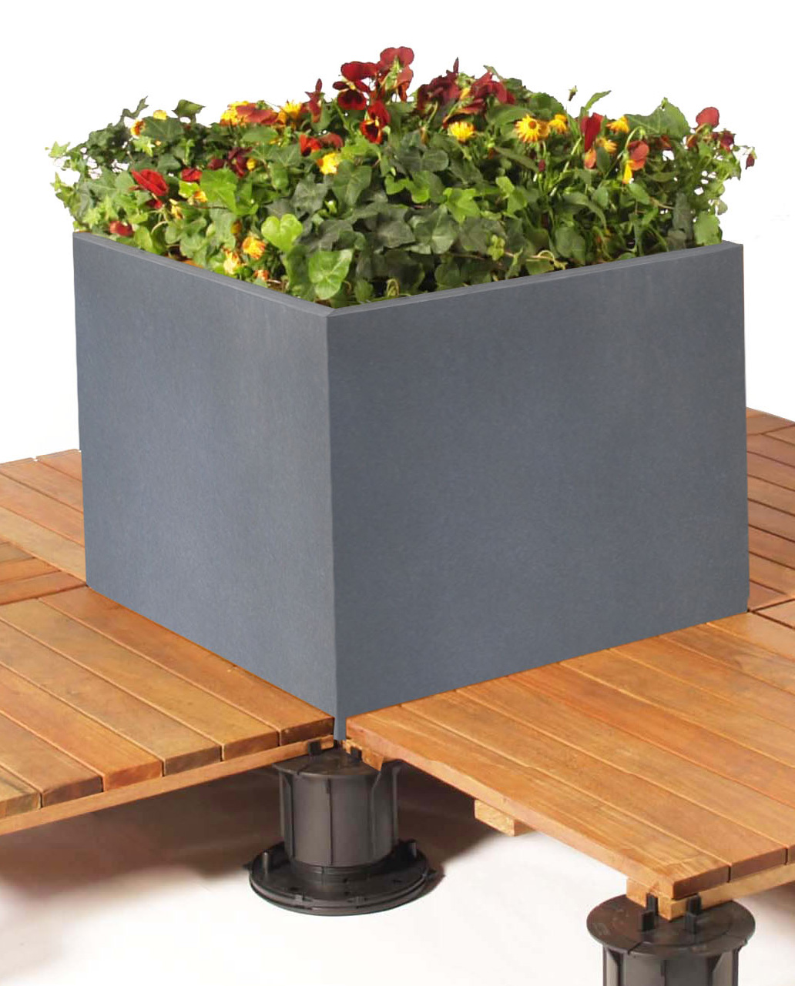 | CUBE-PC242420  CUBE-PC242424  CUBE-PC242436 |  | CUBE-PC482420  CUBE-PC482424  CUBE-PC482436 |  |  | CUBE-PC484820  CUBE-PC484824  CUBE-PC484836 |  | CUBE-PC722420  CUBE-PC722424  CUBE-PC722436 |  |  | CUBE-PC962420  CUBE-PC962424  CUBE-PC962436
BISON  STANDARD  ALUMINUM  CUBE COLORS | 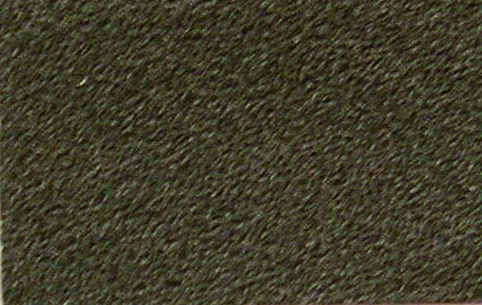  BRONZE  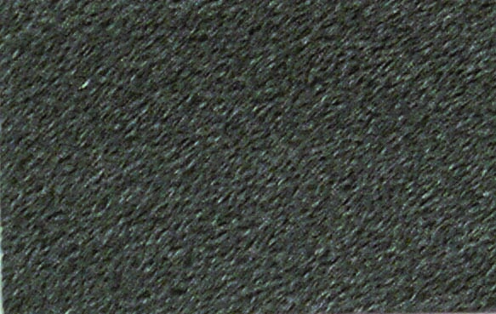  CHARCOAL  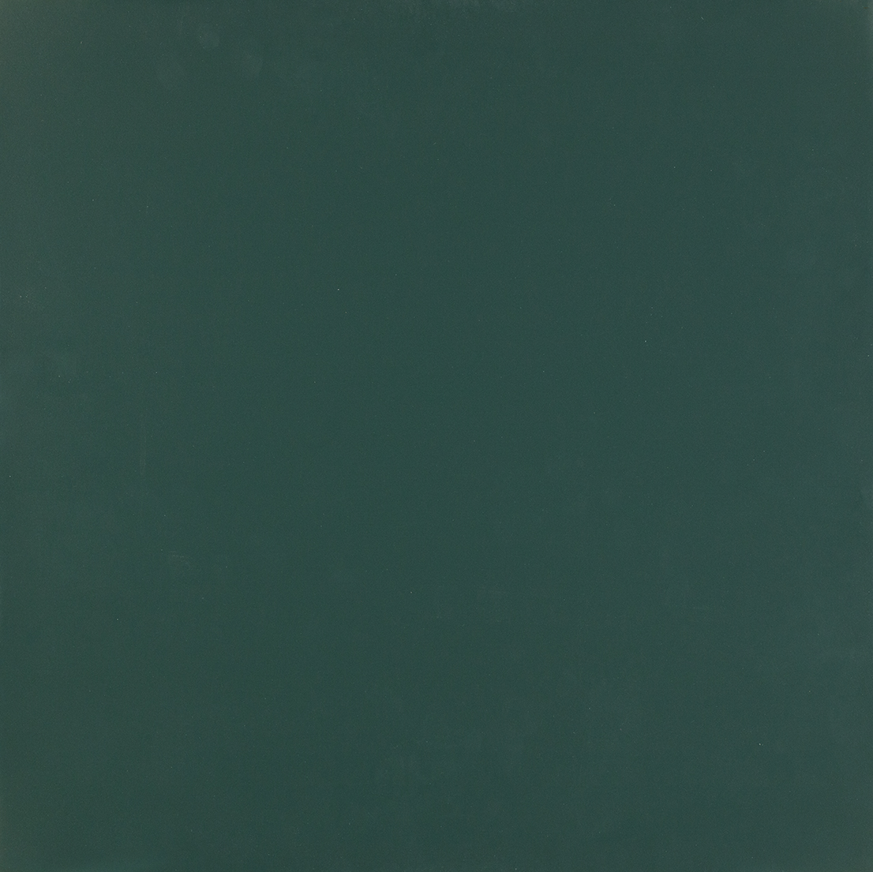  FOREST GREEN |  |   BLACK    RED    TERRACOPPER |  |  | 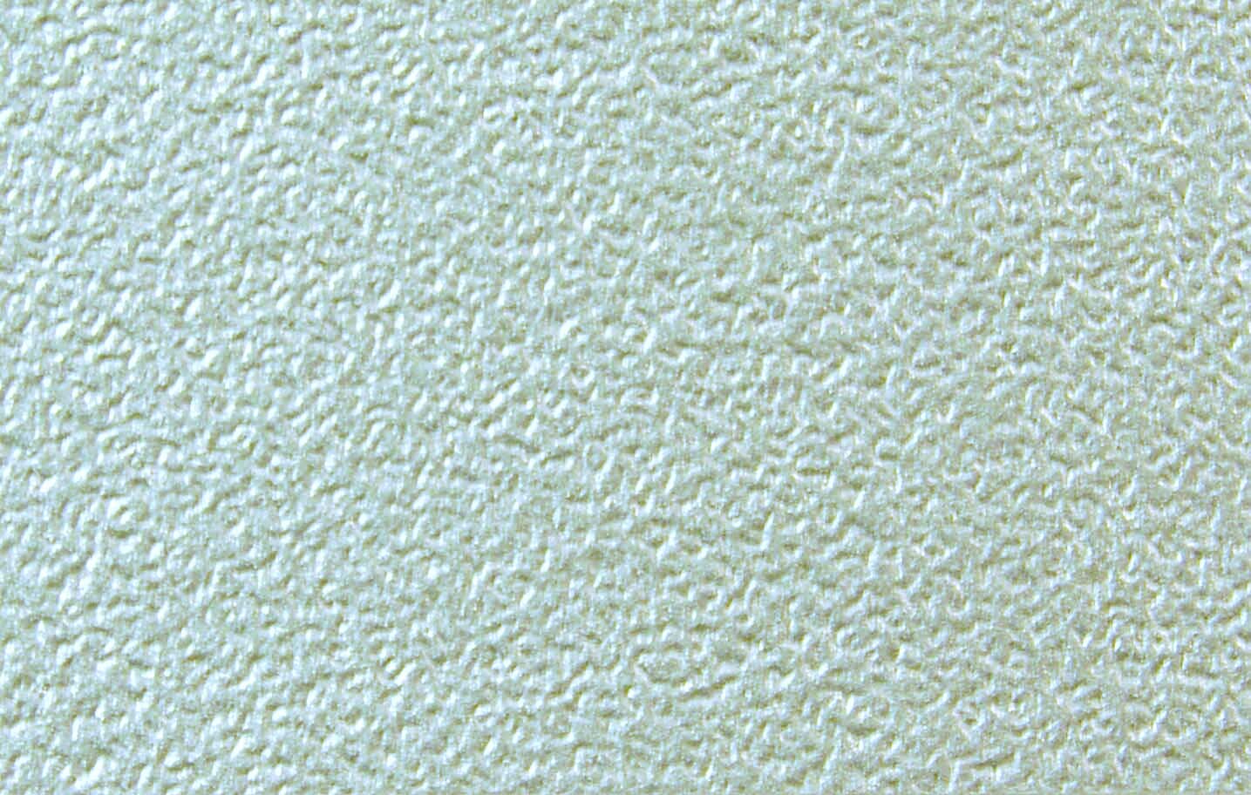  SILVER    WHITE  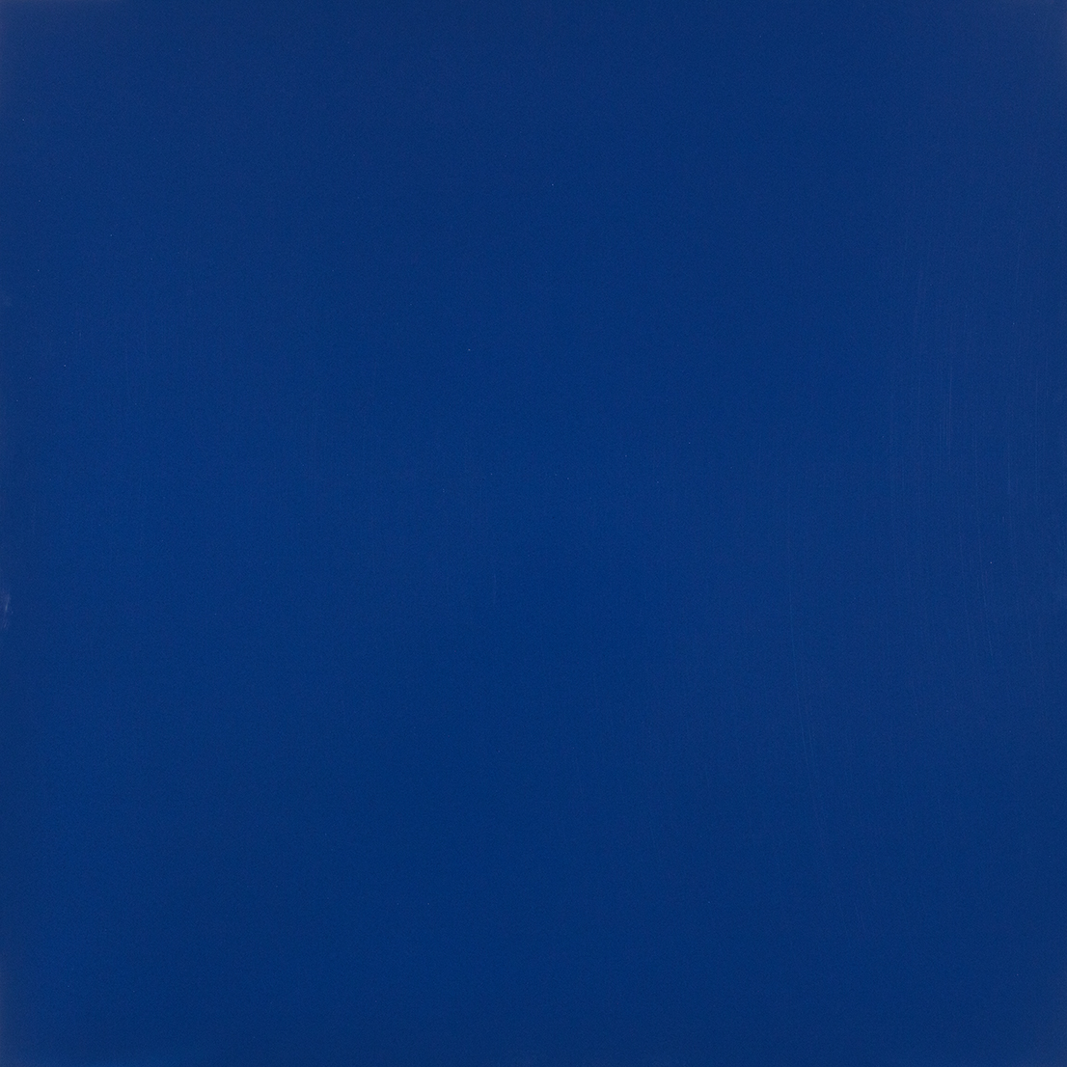  MIDNIGHT BLUE |  |  |  | 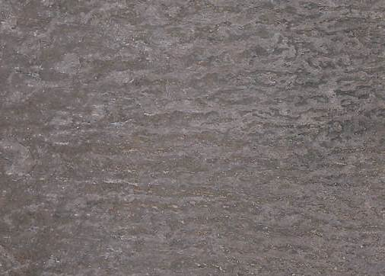  OXIDIZED ZINC PATINA*  *The Oxidized Zinc Patina is a premium “living” finish option, please contact Bison for pricing. Cube Tops are not recommended for use with this finish. Please see the Care & Maintenance for more info.
BISON IPÊ  WOOD CUBES | 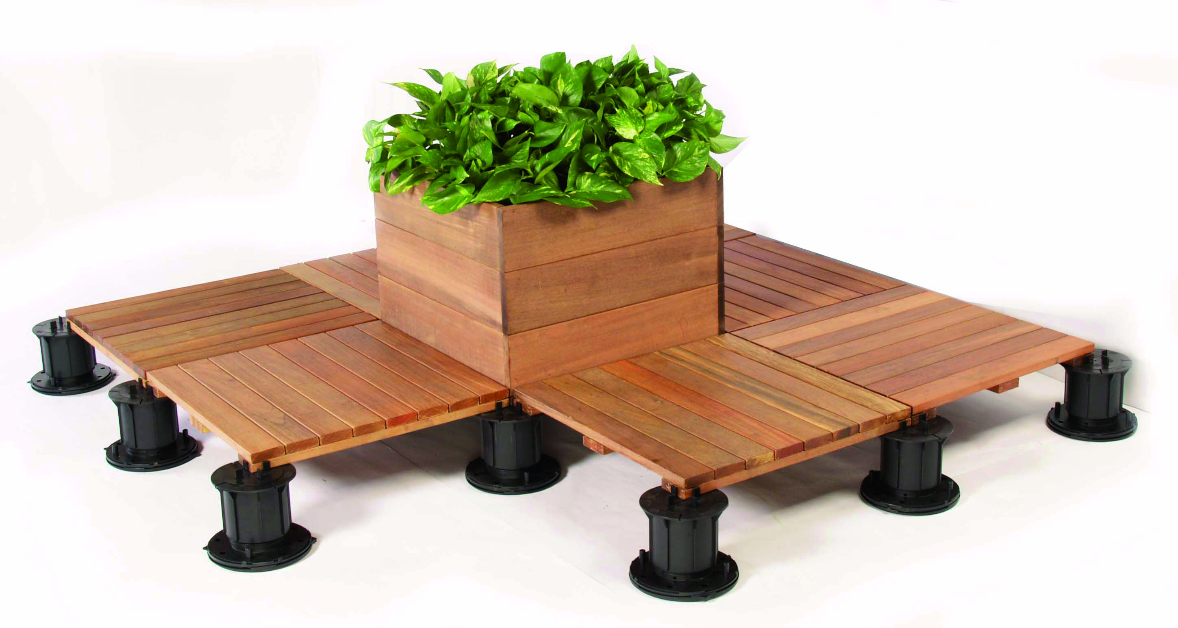 | CUBE-IPE242417-lined  CUBE-IPE482417-Lined |  |  | BISON  CUBE TRAY |  |  | 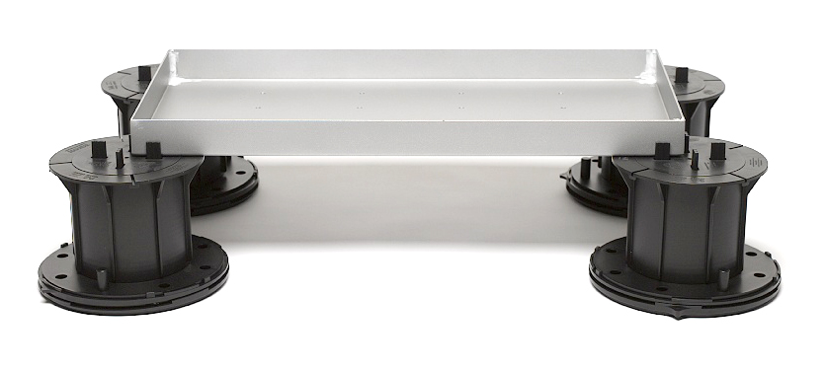 |  |  | CUBE-TRAY24122  CUBE-TRAY48122
BISON SINGLE  IPÊ CUBE TOP | 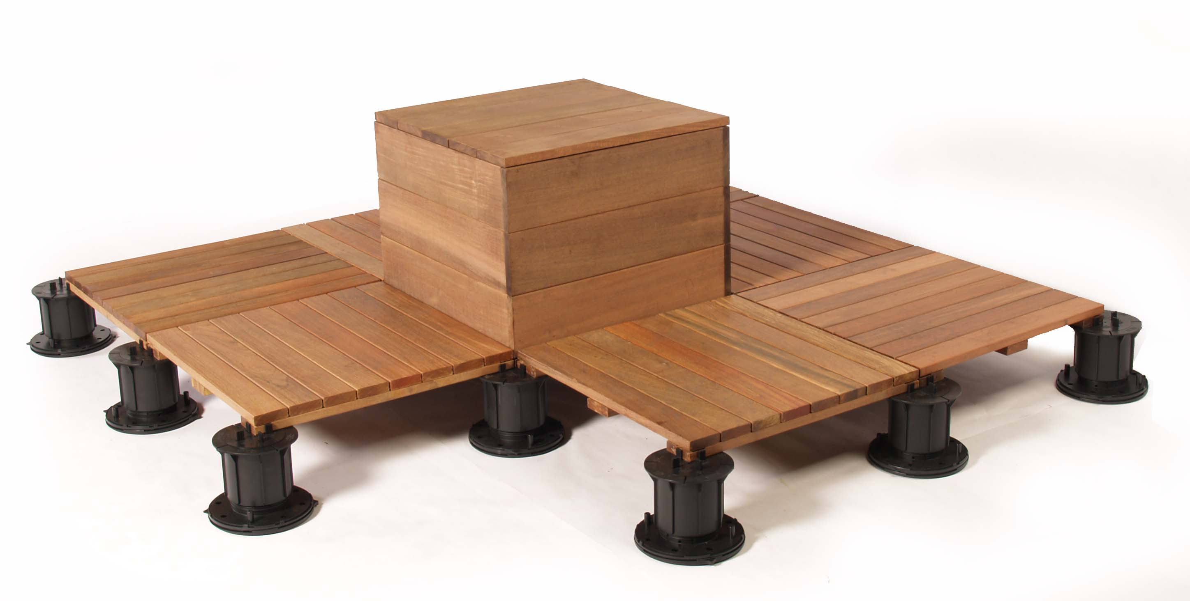 | CUBE-TOP IPE2424  CUBE-TOP IPE2424-AL |  |  | BISON DOUBLE  IPÊ CUBE TOP |  |  | 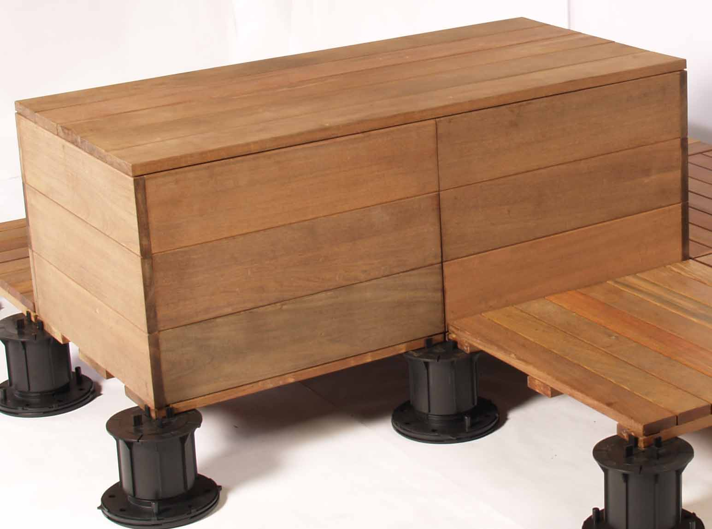 |  |  | CUBE-TOP IPE4824  CUBE-TOP IPE4824-AL
- Custom materials, sizes, and colors are available – please contact Bison Sales (sales@bisonip.com) for more information.
- NOTE: All colors printed herein are representations only – please contact Bison Sales (sales@bisonip.com) for actual color samples.
- Full payment is required at the time of Order – once the size(s) and color(s) are approved, the Order cannot be modified. All Orders must be prepaid and are non-returnable and non-refundable.

