
701 Osage Street, Unit 120 Phone 303-892-0400 November 2021
Denver, CO 80204 Toll Free 800-333-4234
info@bisonip.com Fax 303-825-5988
www.bisonip.com

Ideal for use with Bison Pedestals, the Bison Paver and Paver Tray System offers a beautiful, thin, and lightweight surface material for rooftop decks, outdoor patios, or pool surrounds. The Bison 2CM Paver and Paver Tray System provides weather resistance and protection as well as valuable outdoor spaces for buildings.

Bison 2CM Paver Specification
SECTION 073214 Ceramic and Porcelain Roof Tiles

PART 1 GENERAL

  - SECTION INCLUDES
- Bison 2CM Paver and Paver Tray System

  - RELATED SECTIONS
** NOTE TO SPECIFIER ** Delete any sections below not relevant to this project; add others as required.
- Section 042000 – Unit Masonry and Accessories
- Section 044000 – Stone Assemblies
- Section 044100 – Dry-Placed Stone
- Section 075000 – Membrane Roofing
- Section 077246 – Roof Walkways
- Section 077600 – Roof Pavers
- Section 077616 – Roof Decking Pavers
- Section 093000 – Tiling
- Section 096900 – Access Flooring
- Section 321400 – Unit Paving

  - REFERENCES
** NOTE TO SPECIFIER ** Delete references from the list below that are not actually required by the text of the edited section.
Bison 2CM Paver Testing:
A. ISO 10545-9 Determination of Resistance to Thermal Shock
B. ISO 10545-13 Determination of Chemical Resistance
C. ISO 10545-14 Determination of Resistance to Stains
D. ANSI A137 Dynamic Coefficient of Friction (DCOF)
E. ASTM C373 Standard Test Methods for Determination of Water Absorption and Associated Properties by Vacuum Methods for Pressed Ceramic Tiles and Glass Tiles and Boil Method for Extruded Ceramic Tiles and Non-Tile Fired Ceramic Whiteware Products
F. ASTM C648 Standard Test Method for Breaking Strength of Ceramic Tile
G. ASTM C1549 Standard Test Method for Determination of Solar Reflectance Near Ambient Temperature using a Portable Solar Reflectometer
H. ASTM E1980 Standard Practice for Calculating Solar Reflectance Index of Horizontal and Low-Sloped Opaque Surfaces
Bison Paver Tray and 2CM Paver System Testing:
I. ASTM D5420-10 Standard Test Method for Impact Resistance of Flat, Rigid Plastic Specimen by Means of a Striker Impacted Falling Weight
J. ASTM E136 Standard Test Method for Assessing Combustibility of Materials Using a Vertical Tube Furnace at 750°C
K. ASTM E108 Standard Test Methods for Fire Test of Roof Coverings
L. ASTM E2322 Standard Test Method for Conducting Traverse and Concentrated Load Tests on Panels Used in Floor and Roof Construction

  - SUBMITTALS
- Submit under provisions of Section 013300.
- Product Data: Manufacturer's data sheets on each product to be used, including:
  - Preparation instructions and recommendations.
  - Storage/Handling requirements and recommendations.
  - Installation methods.
- Shop Drawings: Submit shop drawings detailing the installation methods. Coordinate placement with locations noted on the Contract Drawings.
- Fire Resistance Ratings: As required for exterior pedestal supported deck systems by the presiding jurisdiction.
- Wind Uplift Ratings: As required for exterior air permeable pedestal supported deck systems by the presiding jurisdiction.

  - QUALITY ASSURANCE
- Manufacturer Qualifications: All primary products specified in this section will be supplied by a single Manufacturer with five (5) years of experience minimum.
- Installer Qualifications: Bison recommends the Installer have a minimum of two (2) years proven construction experience, be capable of estimating and building from plans and details, determining elevations, and properly handling materials. All work must comply with the Bison installation procedures for pedestals specified herein.
- Special Considerations: The Contractor assumes the responsibility for and must take into consideration the structural capability and adequacy of the structure to carry the static and live load(s) involved, and when appropriate, make sure that the density of any insulation is resistant to crushing and damaging the waterproofing membrane.
- The Bison Pedestal System is not intended to be part of a ballasted roofing system and does not shield the underlying roofing system from wind or other loads. The underlying roofing system must be capable of resisting the full design wind or other loads appropriate for a specific project.
** NOTE TO SPECIFIER ** Include a mock-up if the project size and/or quality warrant taking such a precaution. The following is one example of how a mock-up on a large project might be specified. When deciding on the extent of the mock-up, consider all the major different types of work on the project.
- Mock-Up: Provide a mock-up for evaluation of surface preparation techniques and application workmanship.
  - Finish areas designated by Architect.
  - Do not proceed with remaining work until workmanship is approved by Architect (if applicable).
  - Refinish mock-up area as required to produce acceptable work.

  - DELIVERY, STORAGE, AND HANDLING
- Deliver and store Bison 2CM Pavers and Paver Trays with labels intact and legible.
- Immediately upon receipt inspect all delivered materials to ensure they are undamaged and in good condition. Claims for damages must be made to the Driver/Carrier prior to accepting delivery. Note any visual damage to containers or packaging material on the bill of lading before the Driver leaves. Any damage should be noted on the bill of lading, photographed, and then reported to Bison immediately.
- Store Bison 2CM Pavers and Paver Trays out of direct sunlight in a dry area and/or cover with a tarp.
- Store and dispose of solvent-based materials such as construction adhesives or paint thinners in accordance with requirements of local authorities having jurisdiction.
- In each Order include an additional 5-10% in spare 2CM Paver material to have on hand for damage replacement; depending on the size of the job and as directed by the Architect.

  - PROJECT CONDITIONS
- Bison 2CM Pavers and Paver Trays listed in this section are for use with pedestrian traffic only. Bison 2CM Pavers and Paver Trays are not designed for supporting decks that carry vehicular traffic or equipment, including but not limited to motorized snow removal equipment, window washing, scaffolding structures, ATV’s, forklifts, or any motorized vehicles.
- The recommended minimum installation temperature is 40°F (5°C) and rising. IMPORTANT: Bison 2CM Pavers can become brittle in extremely cold conditions. Use additional caution when working with pavers in temperatures colder than 40°F (5°C). While the thickness and density of Bison 2CM Pavers make for a durable surface material, they can be damaged by mishandling or careless treatment. Please note that if tools, furnishings, or equipment are forcefully dropped on the 2CM Paver, chips, scratches, surface damage, and/or cracking and breakage can occur. Always protect the installed pavers by using sheets of plywood to cover the work area and protect the pavers from chipping and breakage. If breakage occurs, replace the Bison 2CM Paver and Paver Tray immediately.
- It is recommended that the Bison 2CM Pavers and Paver Trays sit above the waterproofing, integral flashing, and/or counter flashing. In situations where the perimeter of the deck contacts the flashing material, protective wall covering should be specified if deemed necessary.
- IMPORTANT: It is the responsibility of the installer to make sure the installation of the Bison 2CM Paver and Paver Tray System meets all local and national codes, including but not limited to the National Electrical Code, regarding installations around swimming pools or other water features, which may require grounding and/or bonding. Failure to do this may void warranties or cause the risk of shock or serious injury for which Bison is not responsible.
- Bison recommends designating zones in each project that provide for heavier features with additional pedestal supports and/or different deck materials under the finished feature. Refer to pedestal specifications and details for additional information on weight capacities and supports. Any feature that creates vibration, cell phone towers, heavy planters, and other similar features require their own separate support designed by an Architect or Engineer of Record. Any deck features that provide a concentrated load must have extra supports in addition to the primary pedestal grid that supports the walk deck. Features supported by legs or feet are not advised and are considered unacceptable because of the consequences of point loading. Bison does not recommend point loading pavers as likelihood for damage is greatly increased. Permanent features and items greater than 250 lbs (113 kg) should be installed directly on pedestals in lieu of installing over surface pavers. Features weighing less than 250 lbs (113 kg) may be installed on top of 2CM Pavers as long as weight is evenly dispersed. Bison recommends designating zones in each project that provide for heavier features with additional pedestal supports and/or reinforced deck materials under the finished pavers.

  - WARRANTY
- At project closeout and upon request, Bison can provide to the Owner or Owner’s Representative an executed copy of the Manufacturer’s standard document outlining the terms, conditions, and limitations of their limited warranty against manufacturing defects for a period of five (5) years. Bison must approve all warranty related repairs, and unauthorized repairs void this limited warranty.
- The Contractor warrants that his work will remain free from defects of labor and materials used in conjunction with his work in accordance with the General Conditions for this project or a minimum of five (5) years.
- It is the responsibility of the Contractor installing the product listed in this section to coordinate warranty requirements with any related sections or adjacent work. Notify the Architect immediately of any potential lapses or limitations in warranty coverage.
- Bison 2CM Pavers are warrantied only when sold and installed with Bison Paver Trays. Bison 2CM Pavers and Paver Trays are covered by a limited five (5) year warranty. Bison 2CM Pavers and Paver Trays are warrantied to the original Owner to be free of defects in material and workmanship for the period of five (5) years from the date of purchase. Damage to the Bison Paver Tray resulting from impact or broken surface material is not covered by the warranty. Bison is not responsible or liable for the cost of any Bison 2CM Paver and Paver Tray that breaks unless such breakage is caused by a defect in material or workmanship. This warranty applies to conditions of normal use, as defined herein, and does not apply to damage resulting from use outside the specifications, abuse, excess weight, impact cracks, surface cracks, chips, variations in color due to weathering or exposure to chemicals, or acts of nature. If a Bison 2CM Paver is deemed defective within the terms of the limited warranty, a replacement Bison 2CM Paver will be furnished at no cost to the customer. Bison’s sole and exclusive liability under this warranty is limited to the replacement cost of any defective Bison 2CM Paver or Paver Tray. The customer acknowledges and understands that matching replacement pavers may not be available after one year from date of purchase and in that case Bison, at its sole discretion, may reimburse the customer for the original cost of the paver(s). Bison must approve all warranty claims, and unauthorized repairs void this limited warranty. This warranty does not cover shipping damage. Immediately upon receipt inspect all delivered materials to ensure they are undamaged and in good condition. Claims for damages must be made to the Driver/Carrier prior to accepting delivery. Note any visual damage to containers or packaging material on the bill of lading before the Driver leaves. Any damage should be noted on the bill of lading, photographed, and then reported to Bison immediately. Please save all product packaging for a short period of time in case return shipping is required. Bison makes no other warranties, either express or implied, with respect to the use of the Bison 2CM Paver and Paver Tray, including warranties of merchantability or fitness for a particular purpose.

  - MANUFACTURERS
**NOTE TO SPECIFIER** Retain one of the following paragraphs 1.9 A-C; to coordinate with requirements of Division 1 section on product options and substitutions.
    - Acceptable Bison 2CM Paver and Paver Tray Manufacturer: Bison Innovative Products; 701 Osage Street, Unit 120, Denver, CO 80204.
Toll Free 800-333-4234. Phone 303-892-0400. Fax 303-825-5988. Email: info@bisonip.com. Web: www.bisonip.com.
    - Substitutions: Not Permitted.
    - Requests for substitutions will be considered in accordance with provisions of Section 012500.

PART 2 PRODUCTS

The Bison Paver Tray was designed and tested specifically for use under Bison 2CM Pavers. The Bison 2CM Paver and Paver Tray System will not prevent the Bison 2CM Pavers or any customer supplied surface material from cracking, chipping, or breaking. In the event the surface material cracks, chips, or breaks, the Bison Paver Tray is designed to prevent an individual from falling through the paver surface to the subsurface below. The Bison Paver Tray is intended to support the surface material after absorbing impact for a limited time. To avoid further damage or injury, the customer MUST REPLACE any cracked, chipped, or broken Bison 2CM Pavers and the accompanying Bison Paver Trays as soon as possible. The Bison Paver Tray is not intended to be a reusable product and must be replaced with the surface paver. IMPORTANT: Wind Uplift Systems must be installed precisely according to separate Wind Uplift Engineering documents not included herein.

2.1 BISON 2CM PAVERS
    - Model: PT-24-BISON
      - Must be used with Bison Model PT-TRAY-2424-4 when installed on Bison Pedestals.
      - Color [Solar Reflectance Index]:
        - PT-24-BISON AXI BROWN CHESTNUT [SRI 30]
        - PT-24-BISON AXI GREY TIMBER [SRI 29]
        - PT-24-BISON AXI WHITE PINE [SRI 63]
        - PT-24-BISON SEASTONE GRAY [SRI 34]
        - PT-24-BISON BLOCK BIANCO [SRI 65]
        - PT-24-BISON MARK CHROME [SRI 47]
        - PT-24-BISON TRUST SILVER [SRI 41]
        - PT-24-BISON TRUST GOLD [SRI 50]
        - PT-24-BISON BLUESTONE [SRI 34]
      - Dimensions: 23.54” x 23.54” x 0.79” (598 x 598 x 20 mm)
      - Weight: 36.38 lbs (16.50 kg) / With Bison Paver Tray: 42.40 lbs (19.23 kg)
      - Weight Distribution: 9.45 psf (46.14 kg/m²) / With Bison Paver Tray: 11.03 psf (53.85 kg/m²)
      - Component Material: Porcelain

2.2 BISON PAVER TRAY
    - Model: PT-TRAY-2424-4
      - Dimensions: 23.43”L x 23.43”W x 0.35”H (595 x 595 x 9 mm)
      - Paver Size: Fits 595-603 x 595-603 mm pavers
      - Weight: 6.02 lbs (2.73 kg)
      - Component Materials:
        - G90 Galvanized 20 ga Sheet Steel – LEED Information--contains approximately: 55.2% Scrap Steel; 41.3% Alloys and other Iron Units; 37.2% Post-Consumer Recycled Content; 18.0% Pre-Consumer Recycled Content
        - Polyurethane Adhesive Sealant – Color: Grey; VOC Content: 29.0 g/l; Service Temperature: -40°F-194°F; Specific Gravity: 1.17 g/cm3; Tack-Free Time @73°F and 50% Relative Humidity: 50-90 minutes; Rate of Cure @ 73°F and 50% Relative Humidity: 3/16 in per 24hrs; Shore A Hardness ASTM C661: 45; Tensile Strength ASTM D412: 450 psi; 100% Modulus ASTM D412: 150 psi; Weight: 0.12 lbs

2.3 BISON 2CM PAVER AND PAVER TRAY FASTENER
    - Model: FS-12 Spline – Secures Bison Paver Tray Assemblies to Bison Pedestals
      - Strongly recommended for use with Bison Pedestals and Paver Tray Assemblies.
      - Components: Spline, long screw, and short screw – long screw for use with Bison Adjustable Pedestals; short screw for use with Bison HD50 and HD75 Fixed Height Pedestals.
      - Weight: 1.41 oz (40 g)
      - Component Material: Mineral Filled High Density Copolymer Polypropylene (Bison #B-PP-2025)

PART 3 EXECUTION

3.1 EXAMINATION
** NOTE TO SPECIFIER ** Revise the next paragraph to accommodate method of installation on the project.
The Bison 2CM Paver and Paver Tray System is not designed for supporting decks that carry vehicular traffic or equipment including but not limited to snow removal equipment, window washing or other scaffolding, ATV’s, forklifts, or any motorized vehicles. Decks must be restrained by perimeter blocking or walls on all sides. Lateral movement greater than 3/16” (4.5 mm) is unacceptable and will be rejected.
- Consult the Manufacturer and/or an Engineer regarding the following:
  - When design requires spacing between Bison 2CM Pavers other than the standard spacing required by the manufacturer.
  - When considering use for other than a surface material (e.g. interior floors, stairs, wall cladding, etc.).
  - When load capacity exceeds the maximums listed.
  - When using Bison 2CM Pavers over pedestals on grade (soil).
  - When using features with point loads greater than 100 lbs (45.36 kg).
  - When installing a deck using pedestals over 36” (914.4 mm) in height.
  - When installing over a joist system.
  - When installing the Bison Paver Tray with surface materials other than Bison 2CM Pavers.
- Prior to Bison 2CM Paver and Paver Tray assembly and/or installation verify the following:
  - All elevations and deck dimensions are consistent with information submitted to Bison for quoting and/or take-off.
  - Special features and anticipated live/dead loads on the Paver Tray Assemblies are compatible with the deck system.
  - Substrates have been properly prepared, and the project is set to proceed. If substrate preparation is the responsibility of another Installer, notify Architect of unsatisfactory preparation before proceeding. Verify all elevations, potential obstructions, and deck dimensions before commencing work.
3.2 PREPARATION
- The substrate surface that will receive the Bison Pedestals and Paver Trays must be:
  - Well compacted if on-grade.
  - Structurally capable of carrying the dead and live loads anticipated if over occupied space.
  - Clean and free of debris that could impair the performance of the Bison Pedestals or Cubes.
- Prior to assembling the Bison 2CM Paver and Paver Tray, Bison recommends that the installer verify the as built conditions of the job and inventory materials.
- Be aware that 2CM Pavers tend to be brittle and fragile. Take time to determine how you will handle and install the pavers to ensure they are not damaged during the installation process. Wear puncture resistant work gloves when handling to protect hands from pinching, cuts, or other possible hand injuries.
- The Bison Paver Tray can be adhered to the desired surface pavers on site PRIOR TO or DURING INSTALLATION. Determine a method for assembling the Bison 2CM Paver to the Bison Paver Tray which:
  - Prevents damage to the 2CM Paver surface.
  - Ensures the Bison Paver Tray is adhered to the 2CM Paver properly (i.e. square/flush).
- Paver Tray Pre-Installation Assembly – Adhering a Bison 2CM Paver to the Paver Tray PRIOR TO INSTALLATION:
  - During assembly, limit exposure to moisture, direct sunlight, and temperatures outside of 40°F to 100°F (5°C to 37°C). CAUTION: Use gloves when handling trays.
  - Squarely place a paver finish face down over four (4x) pedestals. Pull pavers from different pallets and/or boxes in order to achieve an even color distribution.
  - Run a 1/8” DIA. bead of provided 3M adhesive, offset 1/4” from the top outer edge of the tray, and a 1/8” DIA. bead alongside each line of holes. IMPORTANT: For proper adhesion and performance, adhesive must be applied exactly as described. To prevent moisture from entering between paver and tray, a continuous perimeter bead of adhesive must be installed along the edge of the tray.
  - Place the adhesive side of the tray squarely onto the paver, carefully aligning by hand to make sure that the tray does not extend beyond any edge of the paver.
  - Repeating the first four steps, gently lay each new paver on top of the previous tray, rotating placement as assembly continues. Stacking no more than ten (10x) paver tray assemblies high, let sit for 2 to 4 hours, or until the adhesive has cured, before handling.
- Once the Paver Tray Assemblies are stacked, establish the deck layout and arrange pedestals for the initial layout (e.g. T-Method). It is easier to set the preliminary height of the pedestals before installing the pavers. Establish accurate lines, levels, pattern, and perimeter containment. Use a laser level to determine even and level paver height across the desired deck surface.

3.3 INSTALLATION
- Reference the current version of Bison Installation Details and CAD Details for recommended installation procedures. NOTE: Additional Bison Installation Details are available online at www.bisonip.com. If a scenario is encountered during installation which is not covered in the Installation Details, please contact Bison.
- Paver Tray & 2CM Installation Assembly – Adhering a Bison 2CM Paver to the Paver Tray DURING INSTALLATION:
  - During installation assembly, limit exposure to moisture, direct sunlight, and temperatures outside of 40°F to 100°F (5°C to 37°C). CAUTION: Use gloves when handling trays.
  - Place a paver tray on four (4x) pedestals and remove tabs as needed for perimeter placement and also along the path of the FS-12 fasteners.
  - Run a 1/8” DIA. bead of provided 3M adhesive, offset 1/4” from the top outer edge of the tray, and a 1/8” DIA. bead alongside each line of holes. IMPORTANT: For proper adhesion and performance, adhesive must be applied exactly as described. To prevent moisture from entering between paver and tray, a continuous perimeter bead of adhesive must be installed along the edge of the tray.
  - Place the 2cm paver squarely onto the tray, carefully aligning by hand to make sure that the tray does not extend beyond any edge of the paver. Pull pavers from different pallets and/or boxes in order to achieve an even color distribution.
  - Repeat the first four steps, moving out from the perimeter wall.
  - Following the Bison T-Method, as installation progresses out from the perimeter wall, work can also begin along the length of the wall. Place FS-12 fasteners in the channel created between the bottom of the paver and the tray as installation continues outward. These will help to maintain spacing and will be screwed into the pedestals to lock the system together. Once all pavers are installed and adhesive has had time to cure, carefully remove the FS-12 posts with pliers to avoid chipping. DO NOT attempt to hammer the spline posts.
- General Safety Precautions: Wear safety glasses with side shields (or a safety visor which protects one’s face and eyes) when cutting this product, or during any process which may generate excessive dusts and burrs. Respirators must be worn if the ambient concentration of airborne contaminants exceeds prescribed exposure limits (see OSHA Guidelines). Dust masks may be worn to avoid the inhalation of nuisance dust, but dust masks are not adequate protection in environments above the occupational exposure limit. Any cutting or grinding process which could generate airborne particulates should be done outdoors or in a well-ventilated area. Refer to product SDS for more information. If installing Bison Paver Tray Assemblies near Bison Wood Tiles take EXTREME CAUTION to cover the Wood Tiles and prevent grinding dusts from settling on them, as the galvanized dust reacting with the acetic acid in the wood can lead to black spotting on the Wood Tiles as the iron in the dust begins to oxidize into a black-colored rust.
- The recommended minimum installation temperature is 40°F (5°C) and rising. IMPORTANT: Bison 2CM Pavers can become brittle in extremely cold conditions. Use additional caution when handling, working with, or working on top of pavers in temperatures colder than 40°F (5°C).
- The Bison 2CM Paver and Paver Tray System can be installed over Bison Pedestals from 0.50” (12.7 mm) to 36” (914.4 mm) in height. Additional bracing is required for pedestal heights between 24” (609.6 mm) and 36” (914.4 mm). When installing Bison Paver Tray Assemblies, the channels must all run continuously in the same direction. Please refer to the Bison Pedestal Specifications and Installation Details for more information.
- Cutting:
  - Bison Paver Trays and 2CM Pavers may be cut pre- or post-assembly. It is important to select the appropriate tools and blades before cutting the tray and paver materials.
  - For extended lifespan of the cutting blade, consider using a diamond etched porcelain/ceramic blade for cutting 2CM Pavers. When cutting Paver Trays, use either a jigsaw or a steel cutting abrasive wheel. If cutting the Paver Tray before adhering, a sheet metal shear may be used.
  - If cuts are to be radial or curved, score the 2CM Paver along the desired cut line, and then cut through with a smaller diameter circular blade. Scoring the paver (by itself or adhered to the Paver Tray) before cutting helps to prevent fracturing. Consider creating incremental relief cuts up to the score line if the curve causes too much stress for the blade.
  - If cutting the paver BEFORE ADHERING to the tray:
    - Measure and cut the paver along the desired cut line.
    - Place the cut paver atop the tray, aligning finish paver sides with the finish sides of the tray. Trace your cut line onto the tray, and then proceed to cut the tray by itself.
    - Once cut to desired shape and size, use a metal file or angle grinder to smooth any sharp edges or burrs created along the cut line. DO NOT run your fingers along the cut line or any visible burrs.
    - IMPORTANT: Follow Bison’s recommended assembly instructions to adhere the cut tray to the cut paver including the adhesive perimeter seal between tray and paver. Remove any surface debris, and if using a wet cutting technique, dry materials prior to applying adhesive.
  - If cutting the paver and tray AFTER ADHERING:
    - Measure and cut the paver tray assembly along the desired cut line.
    - Once cut to desired shape and size, use a metal file or angle grinder to smooth any sharp edges or burrs created along the cut line. DO NOT run your fingers along the cut line or any visible burrs.
    - Use a small amount cleaner to remove any adhesive from the paver or saw blade, if needed. Wash with a clean rag and mild soap to remove any slippery residue.
    - IMPORTANT: It is necessary to apply a bead of the provided adhesive along any cut edges to maintain a continuous perimeter seal between the tray and paver. Remove any surface debris, and if using a wet cutting technique, dry materials prior to applying adhesive.
  - Paint cut edges with a primer or cold galvanizing spray to re-administer galvanizing layer removed by cutting (exposure to heat, grinding, and/or water) to prevent rusting damage.
- Fastening to Bison Pedestals:
  - Combine the Bison Paver Tray with the Bison FS-12 Spline and Pedestals for an unparalleled combination of collapse resistance, concealed stability, and future cavity accessibility.
  - Bison strongly recommends the use of Bison Pedestals and FS-12 Splines when installing Bison Paver Trays in conjunction with 2CM Pavers. The Bison FS-12 Spline installs quickly, securely, and allows for removal later if desired/required. The FS-12 Splines, available exclusively from Bison, secure the Bison Paver Trays to Bison Pedestals while remaining out of sight without damaging the paver surfaces. A long screw is provided for use with Bison Adjustable Pedestals, and a short screw is provided for use with Bison HD50 and HD75 Fixed Height Pedestals.
  - To install the FS-12 Spline, use the spline posts to slide FS-12 Splines into the channel between two adjacent Paver Tray Assemblies.
  - Use a T-10 star bit and the included long screw to secure the FS-12 Spline to Bison Adjustable Pedestals, or use a #1 square bit and the included short screw to secure the FS-12 Spline to Bison HD50 or HD75 Fixed Height Pedestals. Bison recommends the use of a GRK extended bit from your local hardware store for easier installation.
  - Drive the screw through the center of the spline screw slot and into the center of the pedestal top. Tighten until the screw head base is flush with the top of the spline rib. Remove spline posts with pliers, taking care not to damage the pavers. A small screwdriver can be used to manipulate the spline if the posts have been prematurely removed.

3.4 FIELD QUALITY CONTROL
- During Installation:
  - Inspect construction progress regularly to ensure that grid lines and spacing are being maintained in a straight and consistent pattern, lateral motion is restricted, and the Bison Paver Tray Assemblies and Pedestals are level and not rocking; shim as required. Particular attention should be paid to pedestrian entrances or access points to eliminate potential trip hazards.
  - Inspect to ensure that all perimeter sides of the deck system are securely contained to restrain all sides of the deck. Surface materials must fit tightly against all pedestal spacing tabs, and the gap or space at all perimeter edges must not exceed one tab width or 3/16” (4.5 mm).
  - While Bison 2CM Pavers are durable, they can be damaged by mishandling or careless treatment. Please note that if tools or equipment are carelessly dropped on the paver surface, chips, scratches, surface damage, cracking, and breakage can occur, especially in cold temperatures. Replace cracked, chipped, or damaged Paver Tray Assemblies immediately.
- Immediately Following Installation: The Owner, or the Owner’s Agent, shall carefully inspect the deck system to be positive that:
  - The new deck system is adequately blocked on all sides to contain and prevent lateral movement of the surface decking and related components.
  - There is no more than one tab width spacing between any Paver Tray Assemblies or from perimeter containment [not to exceed 3/16” (4.5 mm)].
  - There is no rocking of Paver Tray Assemblies as foot traffic is applied to the surface decking.
  - All required spacer tabs and fastening kits are installed and secure.
  - The installed 2CM Pavers are protected from damage which may result from continued site construction. Protect installed 2CM Pavers by using sheet(s) of plywood to cover work areas and protect the 2CM Pavers from chipping and breakage. Use caution if using protective plastic sheeting as it may become extremely slippery as construction dust settles.
- After Installation: The Installer and/or Architect has the responsibility of informing the Owner about performing routine maintenance on the deck. This includes:
  - Checking for rocking 2CM Pavers and properly applying shims as the substrate can settle and require pedestal adjustment.
  - Periodically checking for broken, damaged, or missing tab sets and replacing them to limit deck movement.
  - Maintaining intact and structurally sound perimeter containment.
  - IMMEDIATLEY replacing cracked, chipped, broken, or damaged Bison Paver Tray Assemblies or Pedestals. If a 2CM Paver requires replacement, then the Bison Paver Tray which accompanied it also requires replacement even if the damage to the 2CM Paver appears to be only on the “surface”.
  - Retaining extra Bison 2CM Pavers and Paver Trays in a convenient location for future replacements.

3.5 CARE & MAINTENANCE
Test any cleaners in an inconspicuous area first before applying them to the installed deck to determine whether the product you are about to apply serves its intended purpose. In addition, always check with the manufacturer of your roof membrane to ensure that any cleaning solution or product will not compromise or damage the waterproofing membrane. Remember to use safety glasses, respirators, and gloves in handling any materials that contain chemicals. Refer to product manufacturer’s SDS for more information on chemical components and safe handling practices.
- Cleaning: If desired, the Bison 2CM & Paver Tray system may be periodically cleaned. All spills should be cleaned as quickly as possible. Before handling stain removing chemicals, remember to use personal protective equipment such as safety glasses, respirators, and gloves as recommended per manufacturer safety data sheet (SDS). Prior to application of any cleaners, sweep thoroughly and mop with a clean damp mop using a PH-balanced mild household detergent such as diluted dish soap to gently remove dirt, debris, or light stains. Always check with the manufacturer of your roof membrane and drainage system to ensure that any cleaning solution or by-product will not compromise or damage the waterproofing or drainage systems, taking into consideration any and all environmental impact. Always refer to product manufacturer’s SDS for more information on chemical components, safe handling practices, and disposal considerations for local, state, and federal laws. Bison recommends first testing on an inconspicuous area of 2CM paver before applying to the entire deck surface. Bison recommends using ZEP ALL-IN-1 Premium Pressure Wash concentrate (Dilution ratio 1:20 per manufacturer recommendation) for periodic cleaning and maintenance followed by thorough rinsing. Pressure washers may be used on 2CM pavers at a suggested maximum of 1200 PSI. Test an inconspicuous area first, and be careful to clean the entire deck to avoid lap marks. Avoid direct pressure stream on bonding adhesive. Rinse thoroughly with clean, clear water to remove any concentrates or solutions. Rinsing is a critical step in the maintenance procedure to prevent chemical deposit buildup. After rinsing, removing any standing water with a squeegee will help to prevent dirt or chemical deposits from drying on the surface.
B. Deep Cleaning: When necessary, scrub with cotton mop, cloth, sponge, or non-metallic brush. DO NOT use abrasive cleaners, brushes with hard or metal bristles, scouring pads, steel wool, or sandpaper. DO NOT use scouring powders, as these products contain abrasives that may scratch the surface of the paver. DO NOT use vinegar or any cleaners containing acids, alcohols, or strong alkaline agents. Products with high acid or ammonia content are not recommended. Acid washing is not recommended. Acids, like orange extract and vinegar (including any substance with a PH lower than 7) can damage the glazed surface of the paver, and alkaline solutions like ammonia or bleach (including any substance with a PH higher than 7) can discolor pavers and degrade adhesive bond. DO NOT use ammonia, alcohols, calcium hypochlorite, methylene chloride, potassium permanganate, liquid chlorine, or any other strong oxidizing agents. Commercial floor scrubbers and floor buffing machines are not recommended due to their potential to damage the deck system. After referencing the roofing and drainage systems’ safety data sheets to ensure chemical and environmental stability of materials, follow the steps from the cleaning section above. The following cleaners are available for specific stain types:
      - 30 Seconds Outdoor Cleaner (1:1), or Simple Green Concrete and Driveway Cleaner (1:20) for dirt, grease, grime, mold, mildew, and algae
      - FILA CLEANALL (1:30), or FILA PS87 (1:5) for food, drink, dyes, oils, and organic stains
      - FILA DETERDEK (1:5), or Simple Green Lime Scale Remover (1:5) for rust or lime scale stains
When deep cleaning pavers, try to focus on small areas to avoid contact with the underlying tray and adhesive, as they may be adversely affected by chemicals in these cleaners.
C. Sealing: Applying sealer or wax to 2CM Pavers is not recommended.
D. Water and Snow Removal: Always rinse pavers thoroughly after any application of ice-melt to avoid the buildup of salt crystals. After rinsing, squeegee pavers dry.
E. Visual Observation: Check for rocking pavers, and adjust or shim immediately if needed. Failure to do so could cause a tripping hazard. Periodically check spacer tabs and immediately replace broken tabs to limit deck movement. Make sure the edge restraint stays intact and structurally sound.

PROPOSITION 65

WARNING: This product can expose you to chemicals including crystalline silica, which are known to the State of California to cause cancer. For more information go to www.P65Warnings.ca.gov.

END OF SECTION

PT-24-BISON AXI BROWN CHESTNUT  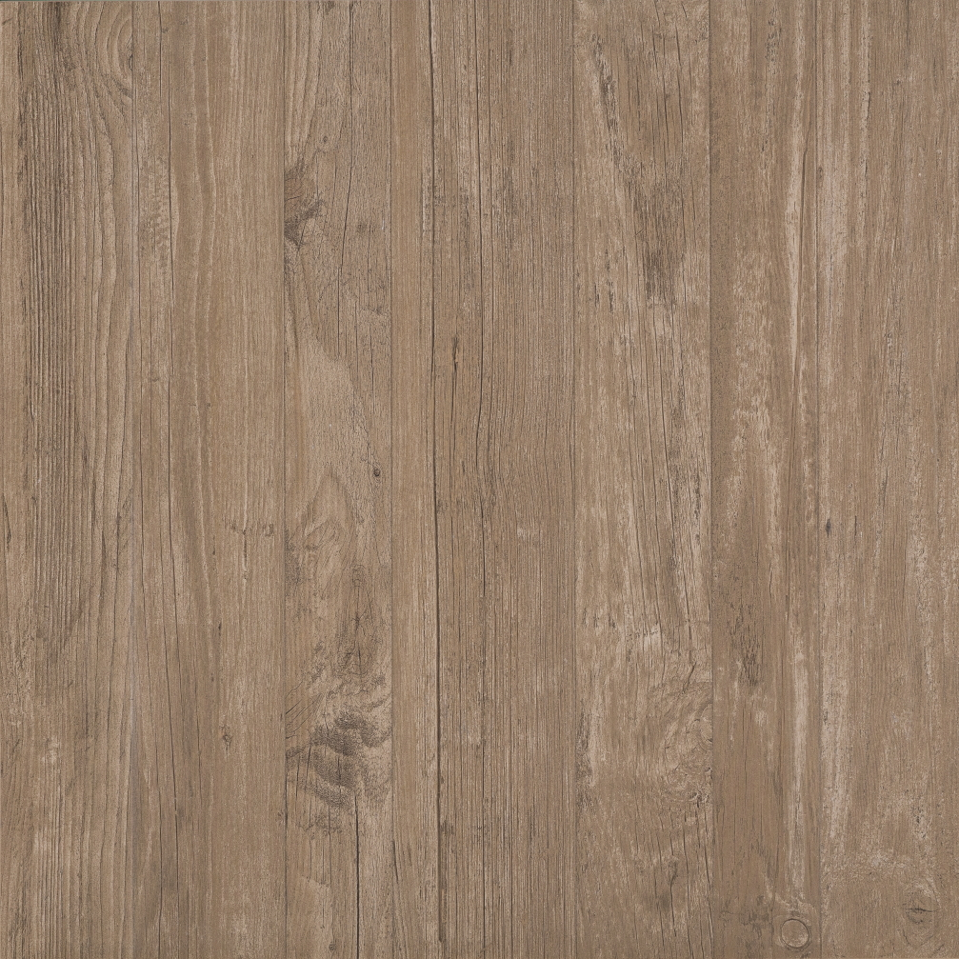 | PT-24-BISON AXI GREY TIMBER  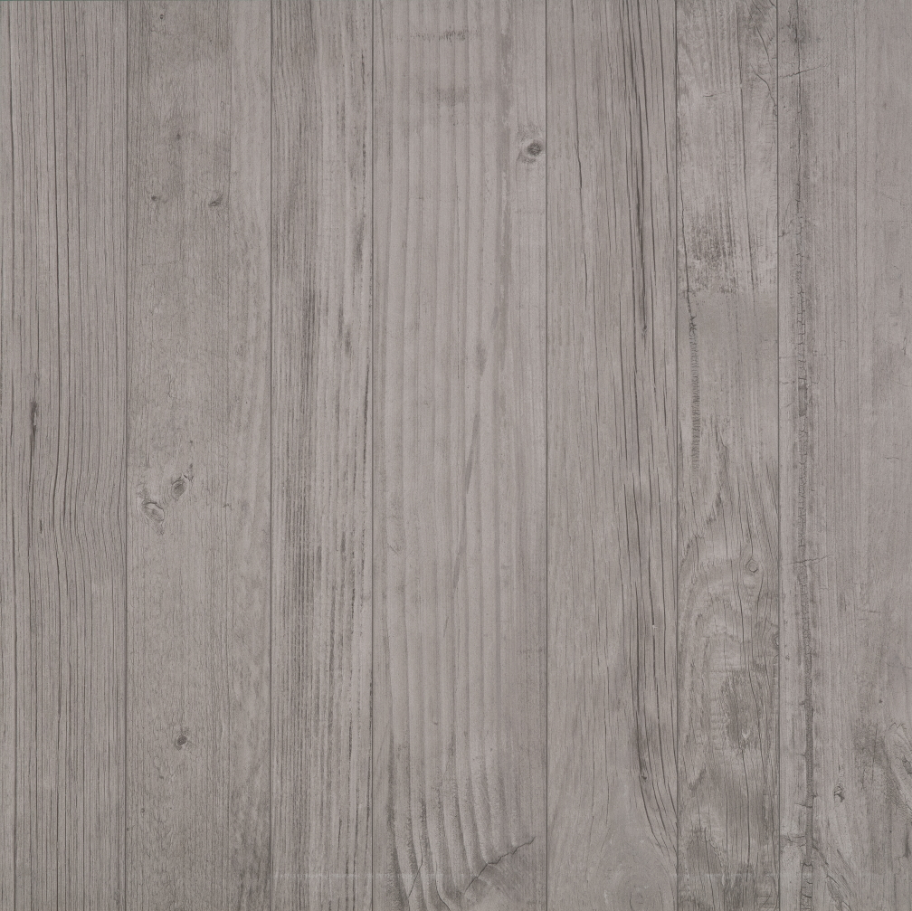 | PT-24-BISON AXI WHITE PINE  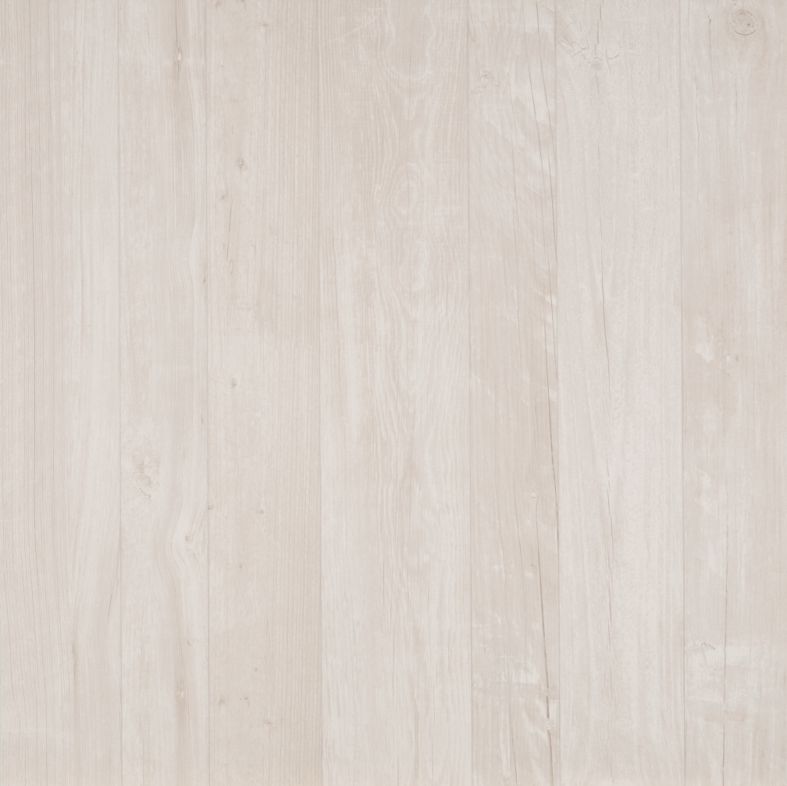
PT-24-BISON SEASTONE GRAY  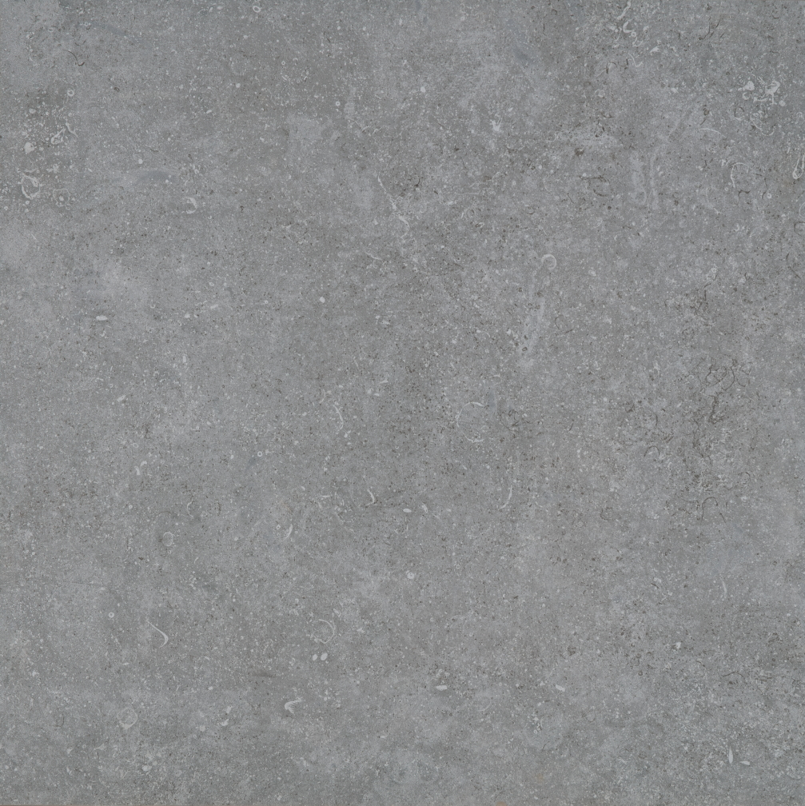 | PT-24-BISON BLOCK BIANCO  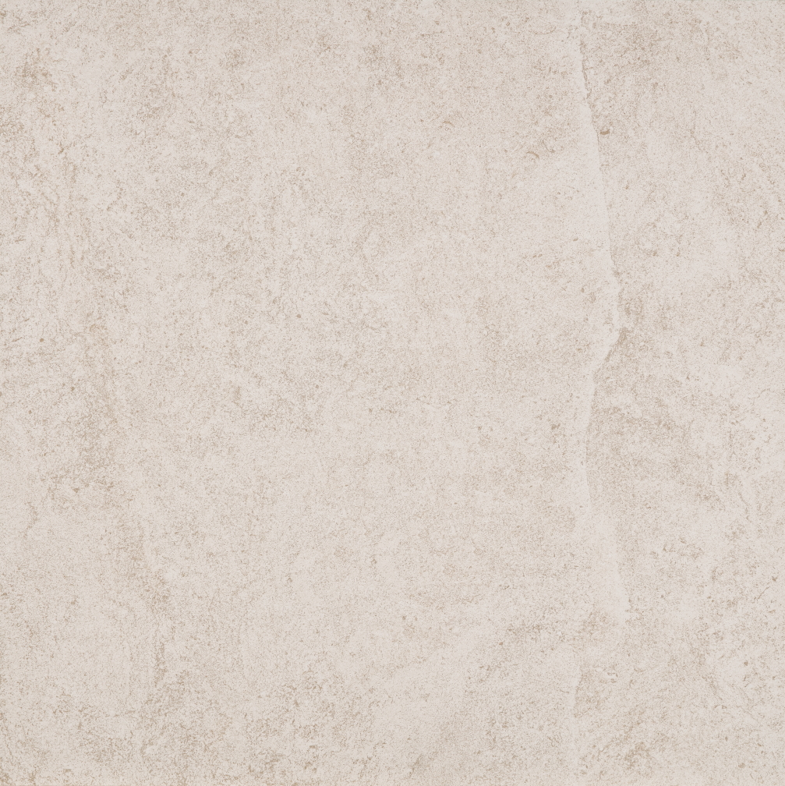 | PT-24-BISON MARK CHROME  
PT-24-BISON TRUST SILVER  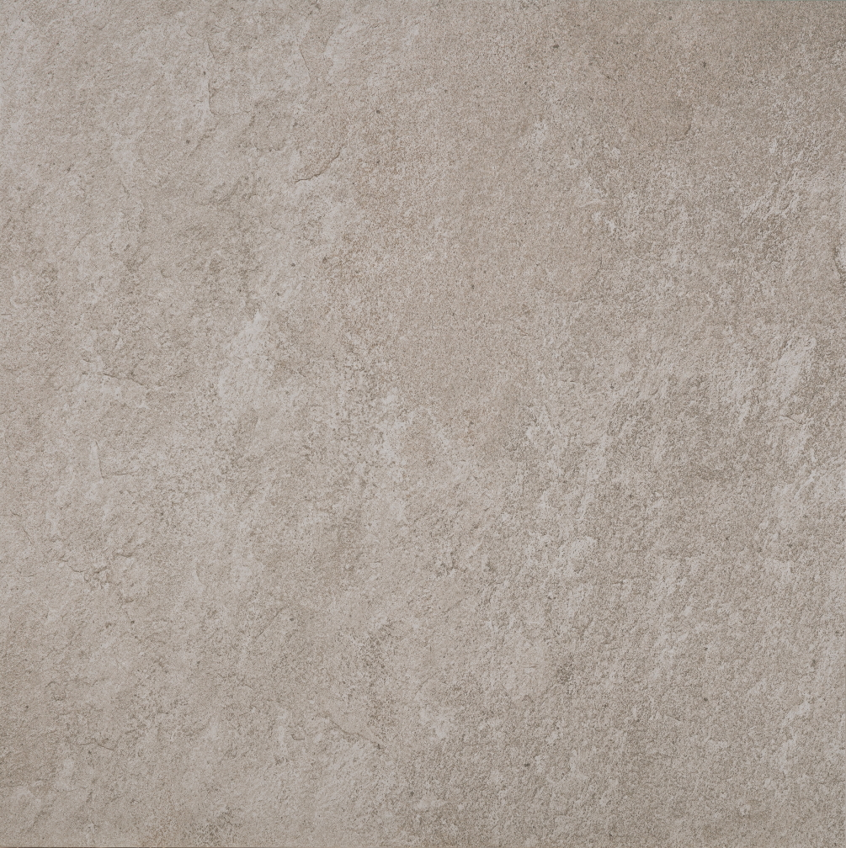 | PT-24-BISON TRUST GOLD  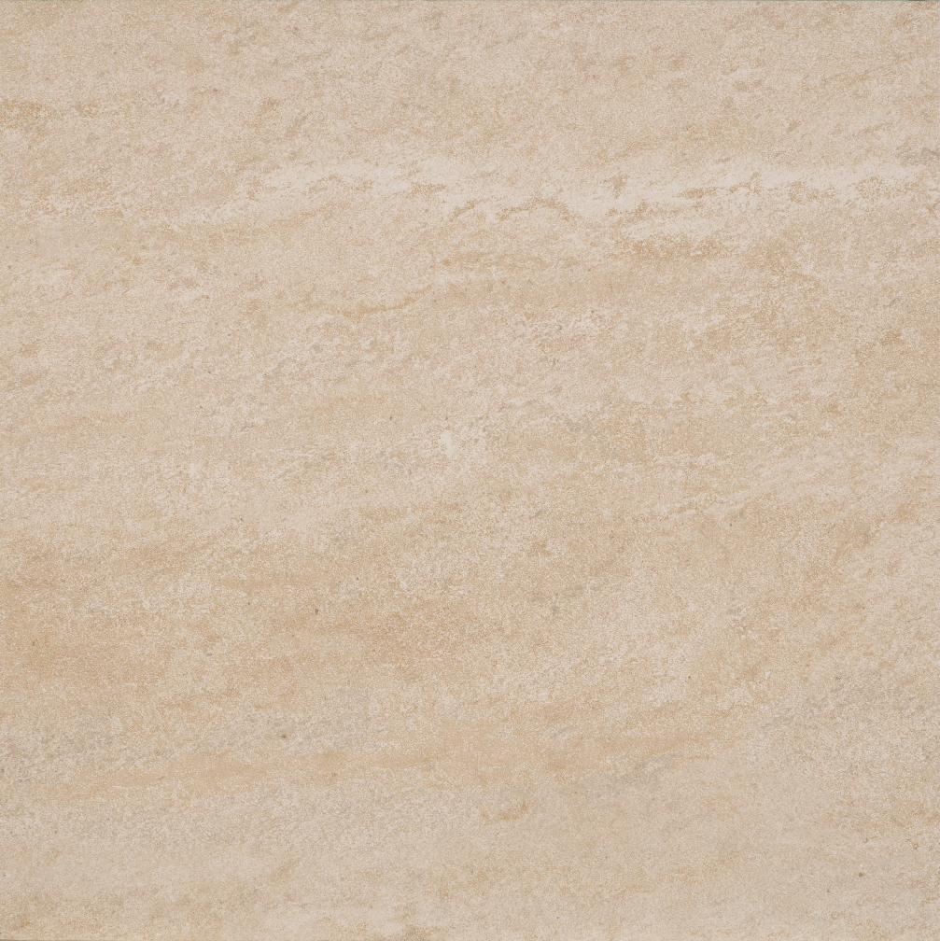 | PT-24-BISON BLUESTONE  
PT-TRAY-2424-4  PAVER SUPPORT TRAY  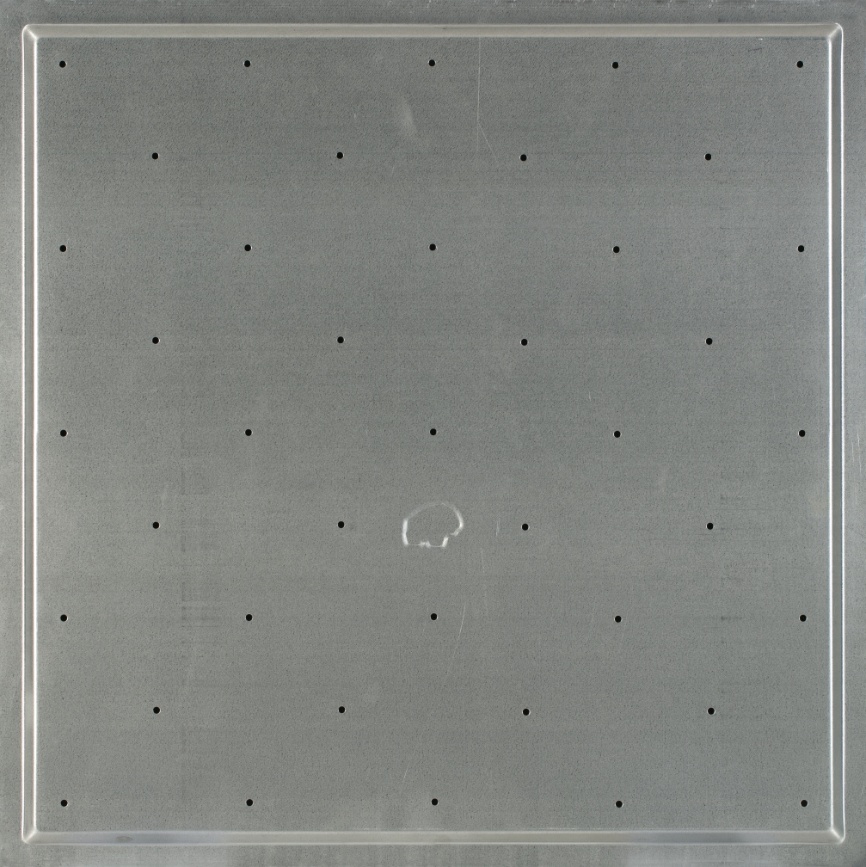 | FS-12  12” FASTENING SPLINE  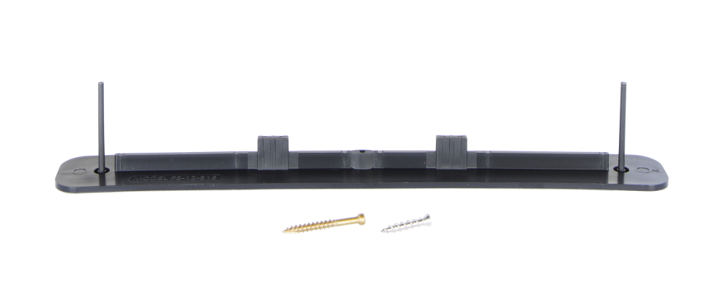  Secures Bison Paver Trays to Bison Pedestals.  Long screw for use with Bison Adjustable Pedestals; Short screw for use with Bison HD50 and HD75 Fixed Height Pedestals. | NOTE: Bison 2CM Pavers are a natural  product and vary in color. Actual colors may differ from pictures; please contact Bison for  color samples.  All products to be installed per current Bison Installation Details and/or Specifications at the time of installation, which can be found online at www.bisonip.com.

